**CITITO**   
(Colombo Initiated Tasked In Tasked Out)

TECHNICAL REPORT

November 1, 2018

Innodata Lanka (pvt) Ltd.

**Innodata Lanka (pvt) Ltd.**

**November 01, 2018**

COPYRIGHT NOTICE

Copyright  (2017-2018) by Innodata Lanka (pvt) Ltd.

**All rights reserved. This material is confidential and proprietary to Innodata Lanka (pvt) Ltd. and no part of this material should be reproduced, published in any form by any means, electronic or mechanical including photocopy or any information storage or retrieval system nor should the material be disclosed to third parties without the express written authorization of Innodata Lanka (pvt) Ltd.**

**VERSION HISTORY**

|  |  |  |  |  |  |
| --- | --- | --- | --- | --- | --- |
| Version | Developer | Reviewed By | Release Date | Approved By | Remarks |
| Beta_v1.0.0.23 | Asela Walawe Durage | Pemalal Aravinda | 1/30/2018 | Ajith Perera |  |
| Beta_v1.0.0.24 | Asela Walawe Durage | Pemalal Aravinda | 2/5/2018 | Ajith Perera |  |
| Beta_v1.0.0.25 | Asela Walawe Durage | Pemalal Aravinda | 2/6/2018 | Ajith Perera |  |
| Beta_v1.0.0.26 | Asela Walawe Durage | Pemalal Aravinda | 2/6/2018 | Ajith Perera |  |
| Beta_v1.0.0.27 | Asela Walawe Durage | Pemalal Aravinda | 2/12/2018 | Ajith Perera |  |
| Beta_v1.0.0.28 | Asela Walawe Durage | Pemalal Aravinda | 2/12/2018 | Ajith Perera |  |
| Beta_v1.0.0.29 | Asela Walawe Durage | Pemalal Aravinda | 2/13/2018 | Ajith Perera |  |
| Beta_v1.0.0.30 | Asela Walawe Durage | Pemalal Aravinda | 2/19/2018 | Ajith Perera |  |
| Beta_v1.0.0.31 | Asela Walawe Durage | Pemalal Aravinda | 2/20/2018 | Ajith Perera |  |
| Beta_v1.0.0.32 | Asela Walawe Durage | Pemalal Aravinda | 3/15/2018 | Ajith Perera |  |
| Beta_v1.0.0.33 | Asela Walawe Durage | Pemalal Aravinda | 3/30/2018 | Ajith Perera |  |
| Beta_v1.0.0.34 | Asela Walawe Durage | Pemalal Aravinda | 3/30/2018 | Ajith Perera |  |
| Beta_v1.0.0.35 | Asela Walawe Durage | Pemalal Aravinda | 4/4/2018 | Ajith Perera |  |
| Beta_v1.0.0.36 | Asela Walawe Durage | Pemalal Aravinda | 4/24/2018 | Ajith Perera |  |
| Beta_v1.0.0.37 | Asela Walawe Durage | Pemalal Aravinda | 5/16/2018 | Ajith Perera |  |
| Beta_v1.0.0.38 | Asela Walawe Durage | Pemalal Aravinda | 5/30/2018 | Ajith Perera |  |
| Beta_v1.0.0.39 | Asela Walawe Durage | Pemalal Aravinda | 5/31/2018 | Ajith Perera |  |
| Beta_v1.0.0.40 | Asela Walawe Durage | Pemalal Aravinda | 6/6/2018 | Ajith Perera |  |
| v1.0.0.1 | Asela Walawe Durage | Pemalal Aravinda | 11/6/2018 | Ajith Perera |  |
|  |  |  |  |  |  |
|  |  |  |  |  |  |
|  |  |  |  |  |  |
|  |  |  |  |  |  |

Table of Contents

1. Introduction 1

1.1. Platform Requirements 1

1.2. Development Requirements 1

2. CITITO Structure 3

2.1. Modules 3

2.2. Functional Requirements 3

2.3. MVC Structure 5

2.3.1. Business Controls 5

2.3.2. Business Objects 5

2.3.3. Business Services 6

2.4. Database structure 6

3. Design of Solution 7

3.1. Use Case Diagrams 7

3.1.1. High-end Admin Use Case 7

3.1.2. High-end PIC Use Case 8

3.1.3. High-end Manager Use Case 8

3.1.4. High-end DCD Use Case 9

3.1.5. High-end Employee Use Case 9

3.2 User Interface 10

3.2.1. Splash Screen 10

3.2.2. User Login 11

3.2.2.1. Admin Panel 12

3.2.2.2. PIC Panel 13

3.2.2.3. Manager Panel 13

3.2.2.4. DCD Panel 14

3.2.2.5. Employee Panel 14

3.3. Admin Panel 15

3.3.1. PIC Registration 15

3.3.2. Change PIC’s Project 17

3.3.3. PTR Cost Resource 18

3.4. PIC Panel 18

3.4.1. Registration Panel [Project Process/Task Codes] 19

3.4.1.1. Project 20

3.4.1.2. Task Codes 20

3.4.2. User Registration Panel [Manager/DCD/User] 22

3.4.2.1. User 22

3.4.2.2. Manager/DCD 23

3.4.3. Task Approval 23

3.4.3.1. Task In/Out Approval 24

3.4.3.2. Pending Records 25

3.4.3.3. Modified Approval 25

3.4.3.4. IDLE Approval 26

3.4.4. Reports 27

3.4.4.1. Dashboard 27

3.4.4.2. Team Details 28

3.4.4.3. Task & Quota 28

3.4.4.4. Workload 30

3.4.4.5. X3 Project 31

3.4.4.6. X3 Team 32

3.4.4.7. X3 User 32

3.4.4.8. X3 User (ProjectWise) 33

3.4.4.9. X3 Tasks 33

3.4.4.10. IDLE & Wastage 34

3.4.4.11. PTR 35

3.4.4.12. Cost 35

3.5. Immediate Manager Panel 36

3.5.1. User Registration 36

3.5.2. Task Approval 38

3.5.2.1. Task In/Out Approval 39

3.5.2.2. Pending Records 40

3.5.2.3. Modified Records 40

3.5.2.4. IDLE Approval 41

3.5.3. Reports 41

3.5.3.1. Dashboard 42

3.5.3.2. Team Details 42

3.5.3.3. Workload 43

3.5.3.4. X3 Project 43

3.5.3.5. X3 Team 44

3.5.3.6. X3 User 44

3.5.3.7. X3 User (ProjectWise) 45

3.5.3.8. X3 Tasks 45

3.5.3.9. IDLE & Wastage 47

3.6. DCD Panel 48

3.7. Employee Panel (Task In/Out) 50

3.7.1. Task In/Out 51

3.7.2. IDLE 51

3.7.3. X3 performance 52

4. Implementation 53

4.1. Code Features 53

4.1.1. Insert, Update, Delete Data 53

4.1.2. Validation Data 55

4.1.3. SQL Queries, SPs 56

5. Messages 57

5.1. Information 57

5.2. Success 57

5.3. Error 58

5.4. Warning 58

6. Conclusion 59

6.1. Introduction 59

6.2. Future Enhancement 59

# 1. Introduction

CITITO (Colombo Initiated Tasked In Tasked Out) is a software solution that the user productivity monitor according to given Quota schedule. The word CITITO is pronounced as **“sɪti.to”**.

The Solution is mainly developed on C# .NET with SQL Server data structure.

## 1.1. Platform Requirements

* Windows 7 or Higher OS
* 4.6.0 .NET Framework
* Disk space (minimum) 4.5 GB(32-bit) /4.5 GB(64-bit)
* 512MB RAM
* 1 GHz Processor

## 1.2. Development Requirements

* Visual Studio 2017 or later
* SQL Server Management Studio 2017 or later
* Reference Libraries
  + ClosedXML.0.93.1
  + DocumentFormat.OpenXml.2.8.1
  + ExcelNumberFormat.1.0.3
  + FastMember.Signed.1.3.0
  + iTextSharp.5.5.13
  + LiveCharts.0.9.7
  + LiveCharts.WinForms.0.9.7.1
  + LiveCharts.Wpf.0.9.7
  + MetroModernUI.1.4.0.0
  + Microsoft.NETCore.Platforms.2.1.0
  + Microsoft.Win32.Primitives.4.3.0
  + NETStandard.Library.2.0.3
  + System.AppContext.4.3.0
  + System.Collections.4.3.0
  + System.Collections.Concurrent.4.3.0
  + System.Console.4.3.1
  + System.Diagnostics.Debug.4.3.0
  + System.Diagnostics.DiagnosticSource.4.5.0
  + System.Diagnostics.Tools.4.3.0
  + System.Diagnostics.Tracing.4.3.0
  + System.Globalization.4.3.0
  + System.Globalization.Calendars.4.3.0
  + System.IO.4.3.0
  + System.IO.Compression.4.3.0
  + System.IO.Compression.ZipFile.4.3.0
  + System.IO.FileSystem.4.3.0
  + System.IO.FileSystem.Primitives.4.3.0
  + System.IO.Packaging.4.5.0
  + System.Linq.4.3.0
  + System.Linq.Expressions.4.3.0
  + System.Net.Http.4.3.3
  + System.Net.Primitives.4.3.0
  + System.Net.Sockets.4.3.0
  + System.ObjectModel.4.3.0
  + System.Reflection.4.3.0
  + System.Reflection.Extensions.4.3.0
  + System.Reflection.Primitives.4.3.0
  + System.Resources.ResourceManager.4.3.0
  + System.Runtime.4.3.0
  + System.Runtime.Extensions.4.3.0
  + System.Runtime.Handles.4.3.0
  + System.Runtime.InteropServices.4.3.0
  + System.Runtime.InteropServices.RuntimeInformation.4.3.0
  + System.Runtime.Numerics.4.3.0
  + System.Security.Cryptography.Algorithms.4.3.1
  + System.Security.Cryptography.Encoding.4.3.0
  + System.Security.Cryptography.Primitives.4.3.0
  + System.Security.Cryptography.X509Certificates.4.3.2
  + System.Text.Encoding.4.3.0
  + System.Text.Encoding.Extensions.4.3.0
  + System.Text.RegularExpressions.4.3.0
  + System.Threading.4.3.0
  + System.Threading.Tasks.4.3.0
  + System.Threading.Timer.4.3.0
  + System.Xml.ReaderWriter.4.3.1
  + System.Xml.XDocument.4.3.0

# 2. CITITO Structure

## 2.1. Modules

1. Admin Module
2. User Management Module
3. Inventory Management Module
4. Projects, Task and Quota Management Module
5. Task-In and Task-Out Module
6. Dashboard - Snapshot
7. Task and Quota Review Module
8. Resource Rates Management Module
9. Project Operator Cost Module
10. Workload Review Module
11. X3 Reports
12. Idle and Wastage Reports
13. PTR Report

## 2.2. Functional Requirements

1. Admin Module
   1. PIC create/update/delete
   2. Change PIC Projects
   3. Resource Code create/update/delete
2. User Management Module
   1. User create/update/delete
   2. Access Control [Common User, DCD, Manager]
   3. Shift map
   4. Project assign/remove/update
3. Inventory Management Module
   1. Shipment create/update/delete
   2. Create Jobs
   3. Assign Tasks to shipments
4. Projects, Task and Quota Management Module
   1. Project create/update
   2. Tasks create/update/delete
   3. Quota table create/update/delete
5. Task-In and Task-Out Module
   1. Task In
   2. Map user output
   3. Task out
   4. IDLE map
6. Dashboard – Snapshot **(Reports)**
   1. PIC dashboard
      1. Team Details
      2. Workload
      3. Project X3
      4. Team X3
      5. User X3
      6. Project wise User X3
      7. Tasks X3
      8. IDLE
      9. PTR
   2. Manager dashboard
      1. Team Details
      2. Workload
      3. Project X3
      4. Team X3
      5. User X3
      6. Project wise User X3
      7. Tasks X3
7. Task and Quota Review Module **(Reports)**
   1. Tasks and Quota based
      1. Average productivity
      2. Highest productivity
      3. Lowest productivity
      4. Median
      5. Standard deviation
      6. Operators above 10% of average
      7. Operators below 10% of average
8. Resource Rates Management Module **(Reports)**
   1. Resource codes and rate view
9. Project Operator Cost Module
   1. Summary of operational cost
10. Workload Review Module
    1. Summary of production workload Team/Project and PIC wise
11. X3 Reports **(Reports)**
    1. Project X3
    2. Team X3
    3. User X3
    4. Project wise User X3
    5. Tasks X3
12. IDLE and Wastage Reports **(Reports)**
    1. Summary of IDLE and Wastage
13. PTR Report **(Reports)**
    1. Summary of PRT generate based on resource rate and production cost

## 2.3. MVC Structure

Solution has been developed MVC architecture. Project has structures in the Visual Studio IDE as below.

* BusinessControls
* BusinessObjects
* BusinessServices

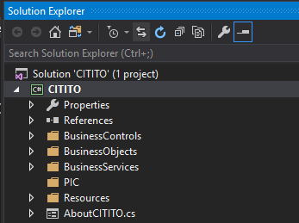

### 2.3.1. Business Controls

All the controls placed on here, for this solution MD5 hash algorithm used for user management.

### 2.3.2. Business Objects

Data modules are created on here that related on all the components.

### 2.3.3. Business Services

Queries that CITITO modules requires created on here with SP’s/SQL queries.

## 2.4. Database structure

All required data table structure created on CITITO database in remote server. Following is show the Data diagram of this solution.



# 3. Design of Solution

## 3.1. Use Case Diagrams

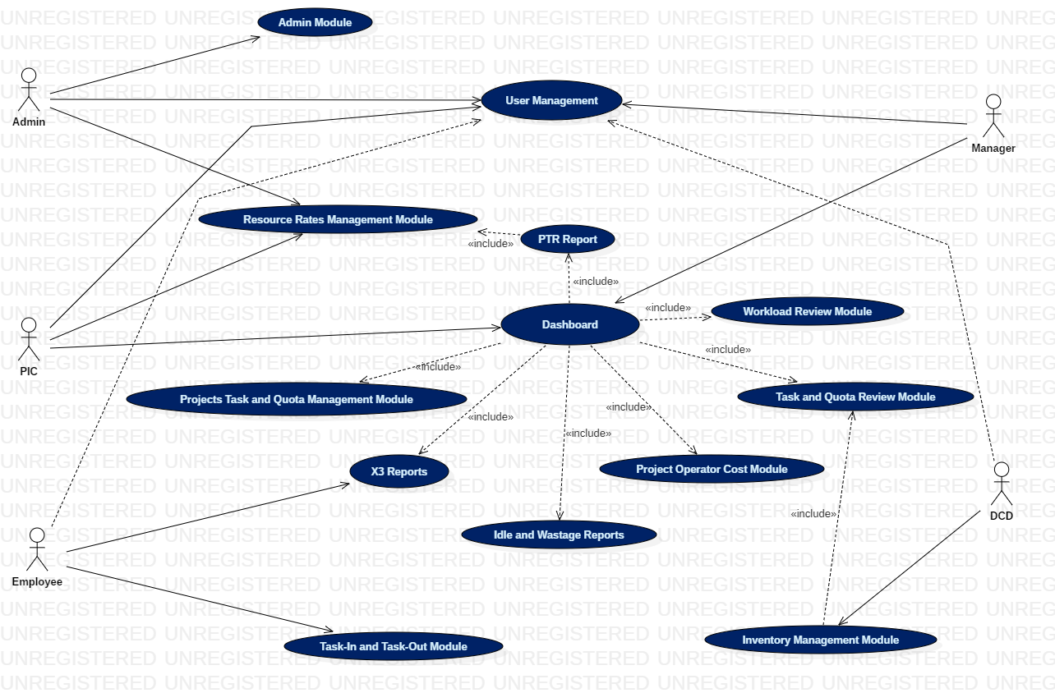In this solution five actors are relate to the comprehensible modules. CITITO use case diagram shown as below.

### 3.1.1. High-end Admin Use Case

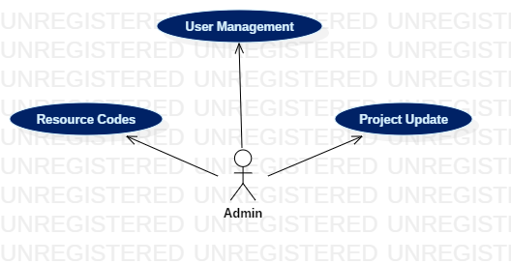

### C:\Users\7AO\Desktop\PICHighEnd.png3.1.2. High-end PIC Use Case

### C:\Users\7AO\Desktop\ManagerHighEnd.png3.1.3. High-end Manager Use Case

### 3.1.4. High-end DCD Use Case

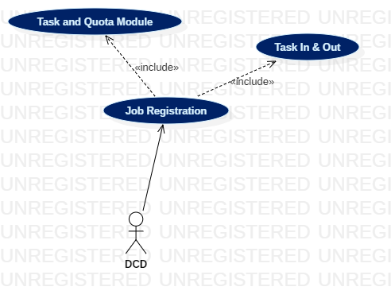

### 3.1.5. High-end Employee Use Case

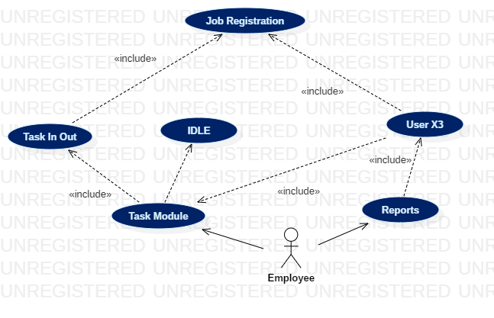

## 3.2 User Interface

CITITO user interfaces designed using Metro UI Framework. This framework included more flexible and materialized UI components which end user preferred.

### 3.2.1. Splash Screen

This is the first screen that user run the CITITO executable. This contains the solution version and it has mapped to the table “**tbl_CITITOVersion**” in CITITO database. It always validate solution version. Therefore once any version update there, may have to update same version in “**tbl_CITITOVersion**” table too.



### 3.2.2. User Login

User must be valid credentials to the use CITITO application. All the credentials can be created by Admin, PIC and Manager. Admin is responsible to create PIC, PIC responsible to create Manager and Employee, Manager undertakes to create Employee credentials.

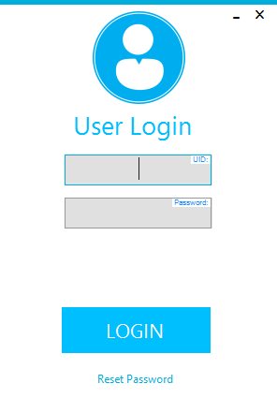

Password reset function is available to change their passwords. Password must be at least 8 characters.

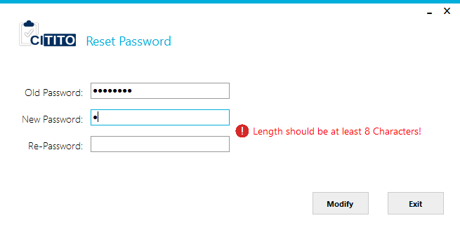

Each users will get operation window according to their access type. There are 5 access types in this solution.

1. Admin
2. PIC
3. Immediate Manager
4. DCD
5. Common User

#### 3.2.2.1. Admin Panel

#### 3.2.2.2. PIC Panel

#### 3.2.2.3. Manager Panel

#### 3.2.2.4. DCD Panel

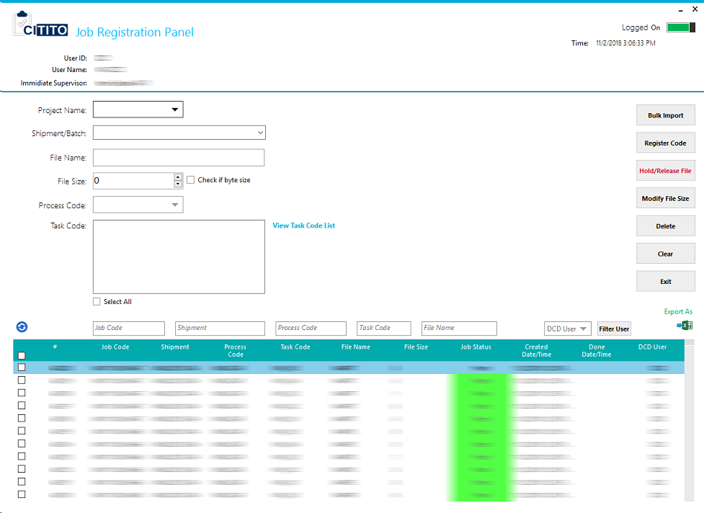

#### 3.2.2.5. Employee Panel

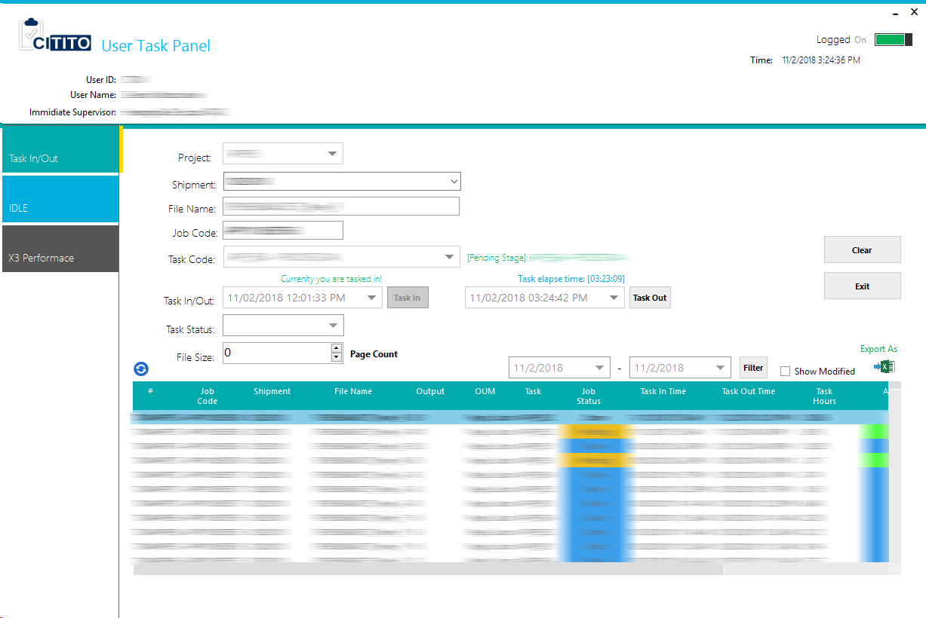

## 3.3. Admin Panel

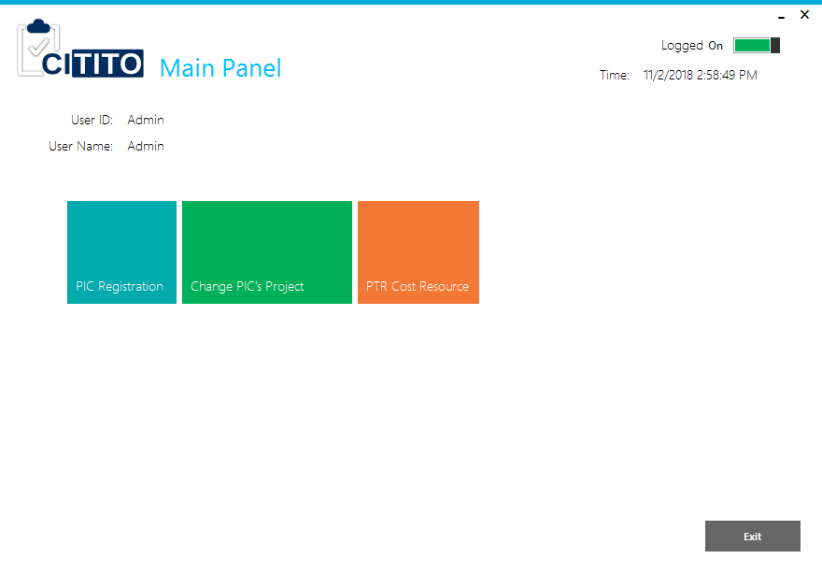Admin user is the pioneer of CITITO solution who makes PIC profiles. Only admin can make profiles and change PIC projects. In addition admin can be able to import Resource codes to the CITITO. These resource codes will effected to the all Employees once they are registered to the system.

Admin panel has three types of functions.

1. PIC Registration
2. Change PIC’s Project
3. PTR Cost Resource

### 3.3.1. PIC Registration

Admin user responsible to the PIC profile create in CITITO application. After PIC registration process PIC can map their Project and Quota to the application. In the old TITO application was responsible this part to the Admin user. Following figure is shown the form of PIC registration panel.

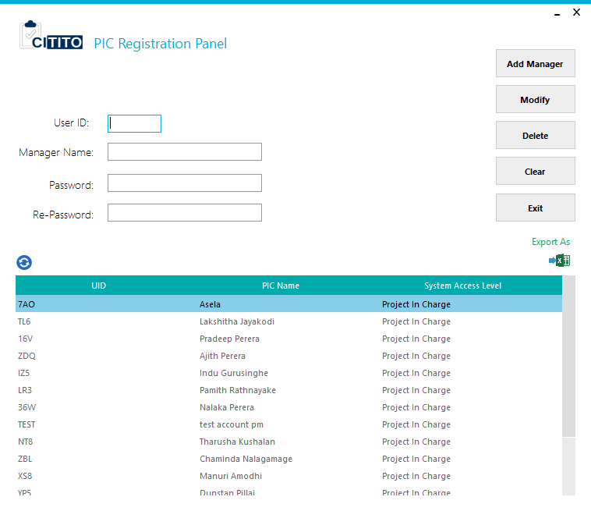

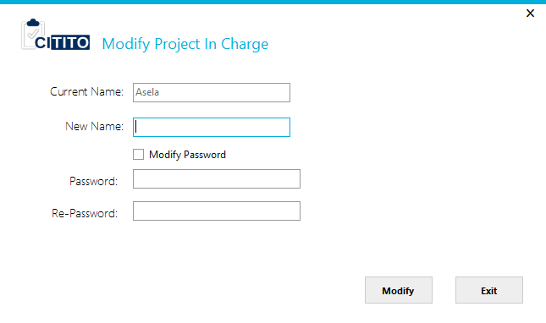If PIC name or password modification available, admin can make the changes selecting PIC from the list and clicking modify button.

If PIC deletion available, all the fresh PIC can delete at the time. Otherwise if there any project owned, PIC must remove from the system after transferring their projects to another PIC. PIC transferring dialog will shows as below.

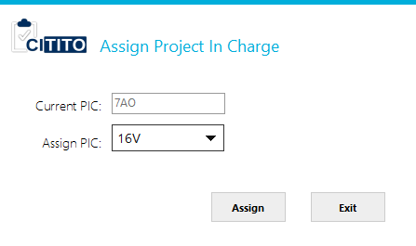

### 3.3.2. Change PIC’s Project

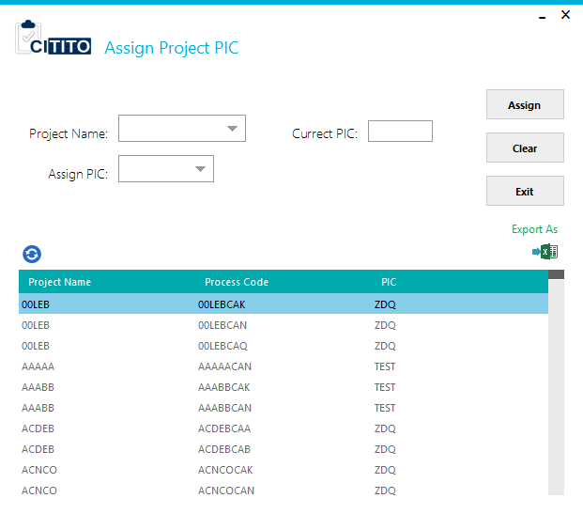From this function, admin can assign PIC owned project into another PIC in the system. Select project that need to be changed from the Project Name dropdown and current PIC will show next to the dropdown. Then admin can select the assigner from Assign PIC dropdown.

### 3.3.3. PTR Cost Resource

In this function responsible to import employee’s resources cost IDs to the system. The template of resource cost table places on “**BulkImportTemplate**” folder and here is the sample of image.

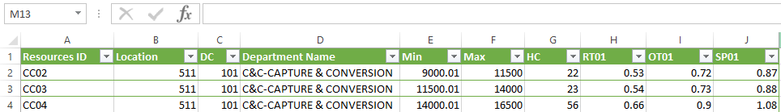

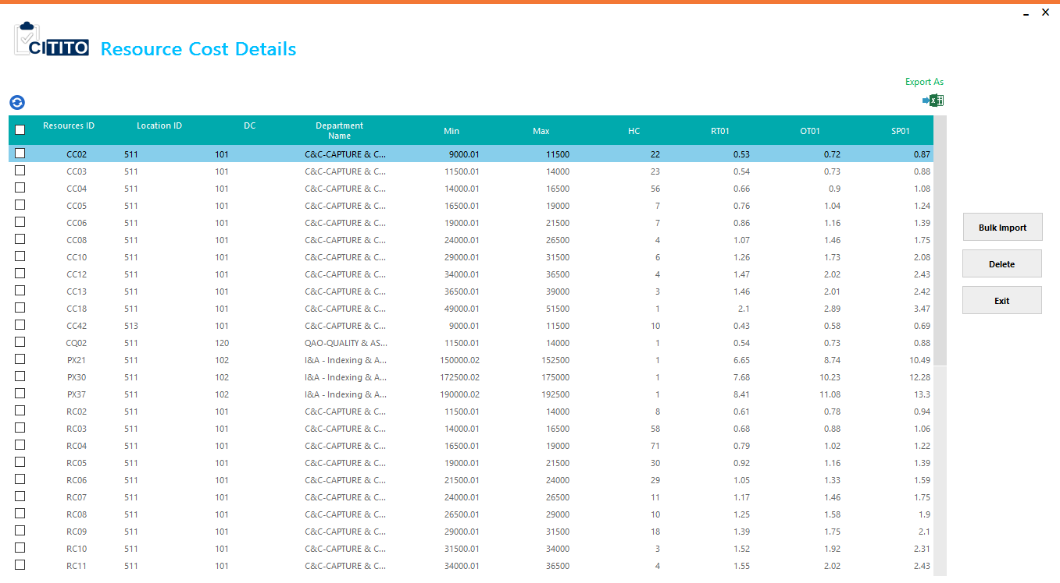

## 3.4. PIC Panel

Any login has “Project In Charge” credentials, system will automatically redirect to the PIC Panel. In the main panel PIC can role below certain functions.

1. Registration Panel [Project Process/Task Codes]
2. Task Approval
3. User Registration Panel [Manager/DCD/User]
4. Reports

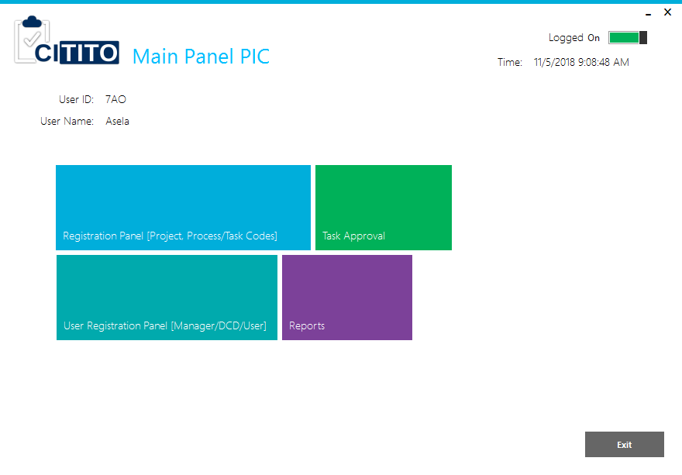

### 3.4.1. Registration Panel [Project Process/Task Codes]

Matrix defined all projects and task codes can be adopt to the CITITO system. There are two tabs available to register Project and Task Codes. PIC is only responsible to this function.

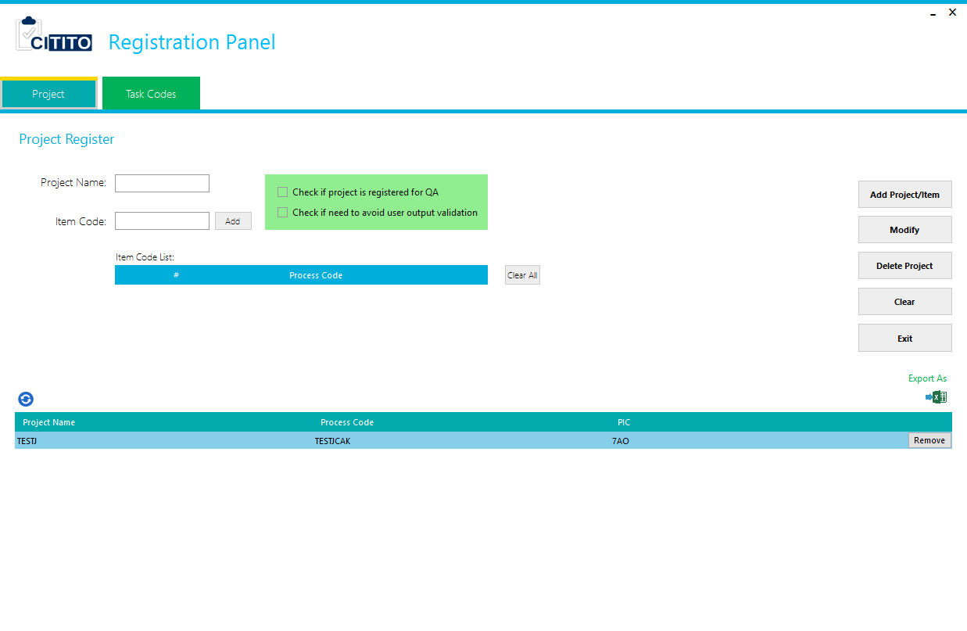

#### 3.4.1.1. Project

PIC must be fill Project Name and the Item codes according to the Matrix. The project name inndoata is standardize in to 5 characters.

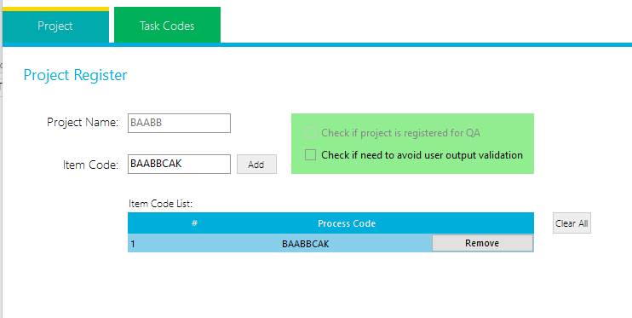

For the QA project registration PIC must be checked “**Check if project is registered for QA**”.

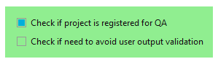

Another option is given to task output validation from employee task in out stage. Some projects/tasks such as byte size available, have not popper output evaluation before register the tasks. Therefore these type of tasks will calculate the output once user done their job/task. Meantime user output validation is not allowed to the task that user tasked in.

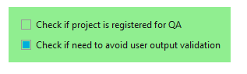

Once registered project and related tasks, PIC can click Project/Item button. CITITO also allowed only task registration for the existing projects.

#### 3.4.1.2. Task Codes

PIC can update relevant quota details for the registered Projects and Item Codes. Matrix mapped task quota should be registered here. Task Code/ID will automatically generated from CITITO system, therefore old TITO system owned task codes are not valid for this system. (Ex: E1, E2, E9, E10, E11, E13, E14).

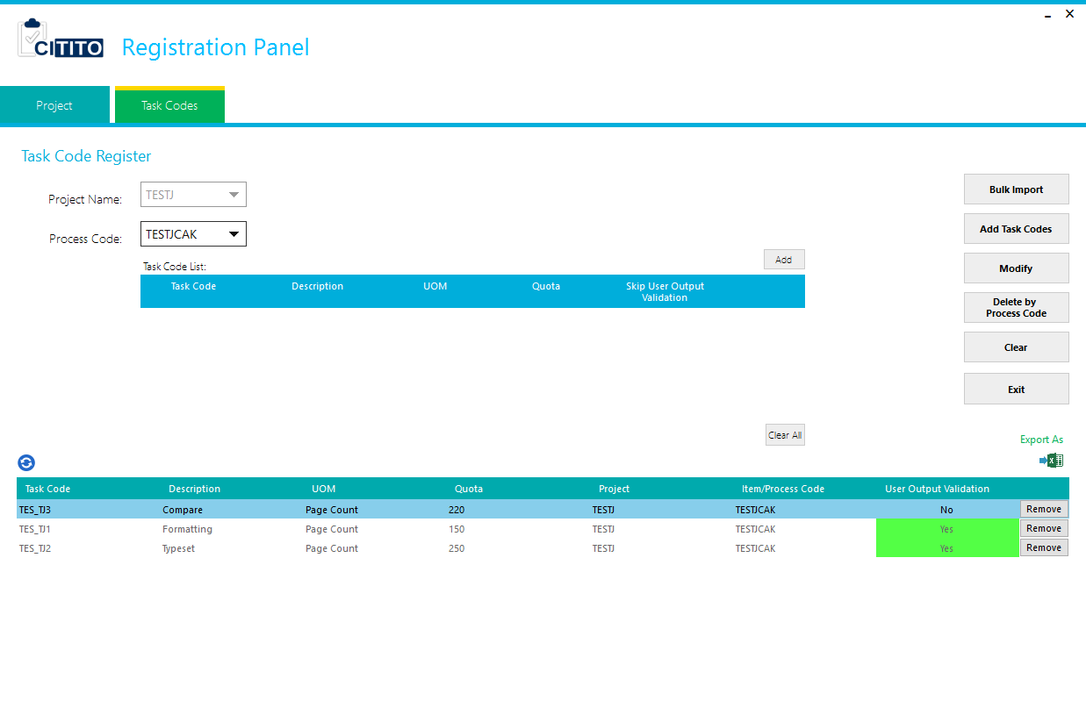

PIC must fill following details to the task.

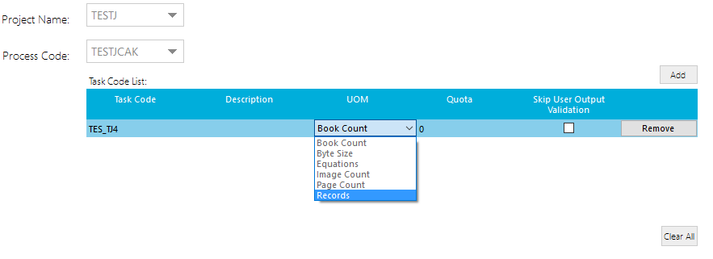Description, UOM (Unit of Measurements), Quota and Skip User Output Validation

Additionally PIC can delete registered task code one by one or bulk with the item code by using “Remove” or “Delete by Process Code” buttons.

### 3.4.2. User Registration Panel [Manager/DCD/User]

PIC is responsible to create Manage, DCD, Employee user profiles to the CITITO system. There are two tabs to user registration panel for Employees and Manage/DCD.

#### 3.4.2.1. User

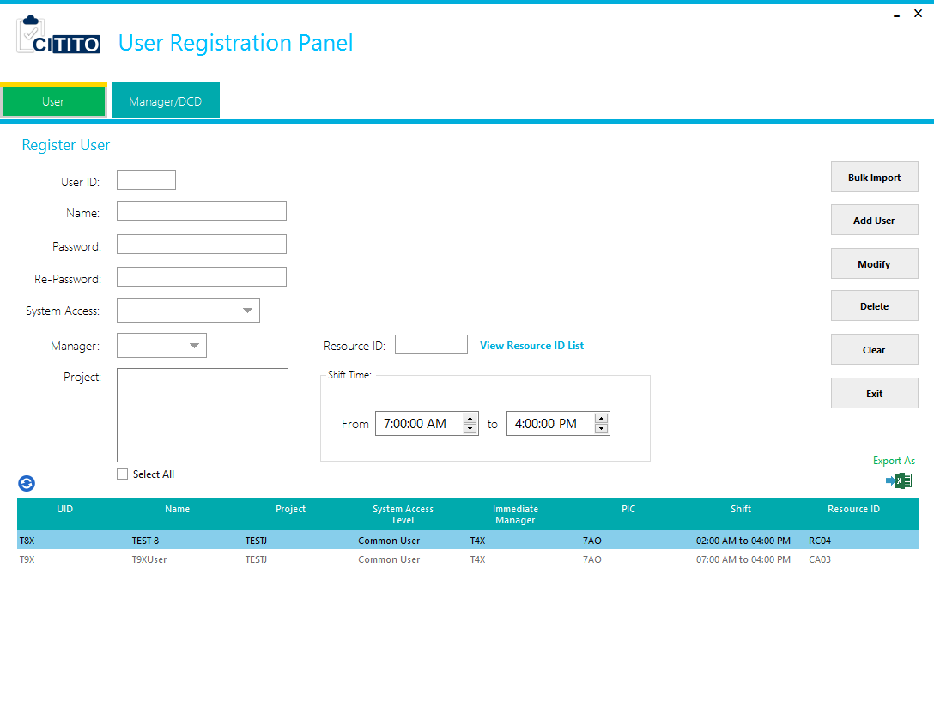

Employee has individual resource code and shift, PIC need to be find out resource code according to the salary scale and fill resource ID.

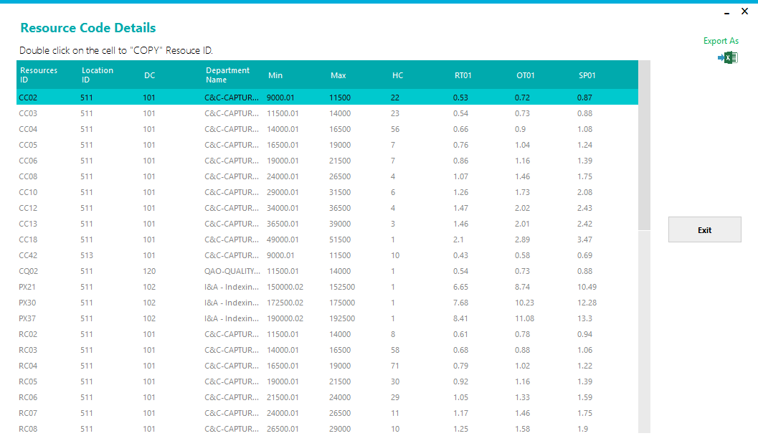

#### 3.4.2.2. Manager/DCD

Manager/DCD user can register by PIC. Both manager and DCD profiles differed by system access levels while registration. They are,

* Immediate Manager
* 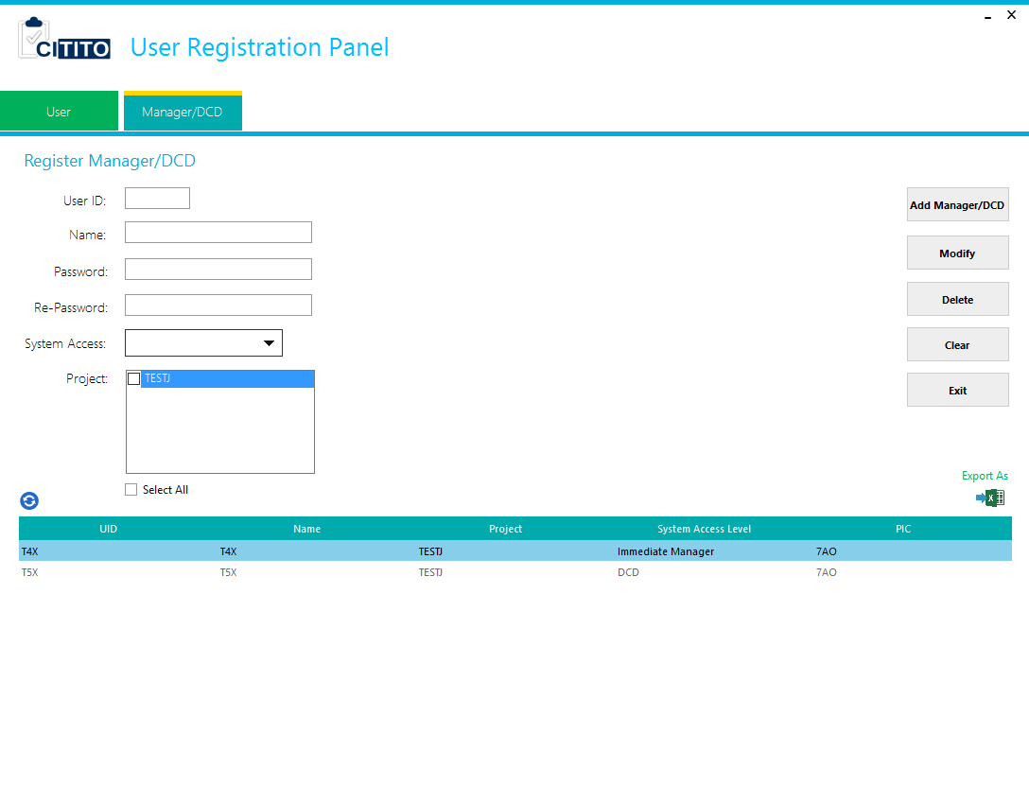DCD

**Note:** Manages must be registered before create an employee.

### 3.4.3. Task Approval

All employees’ task records, modified task records and IDLE records approvals can be function from this panel. Once approve any task record they will effect to the user evaluation process in each and every midnight in a day. Therefore today approvals X3’s will be shown in tomorrow.

For PIC access level, task approval panel is giving following functions.

1. Task In/Out Approval
2. Pending Records
3. Modified Approval
4. IDLE Approval

#### 3.4.3.1. Task In/Out Approval

Employees done task records for approvals will show in this tab. This also load in default once PIC clicked on Task Approvals.

On this tab offer filters to the PIC for filter by Manager, Emp0loyee ID, PCP/Job Code, filename or giver time period. Further it has function to see previous approval records history.

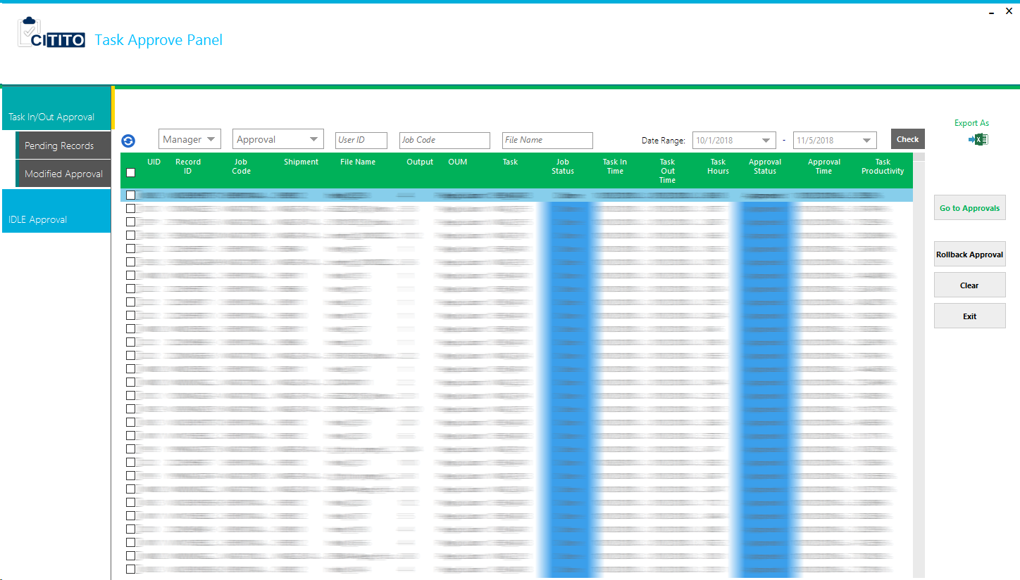

#### 3.4.3.2. Pending Records

This function is given to check all employees’ pending task records. It was given only for reference and not enable any function to approvals.

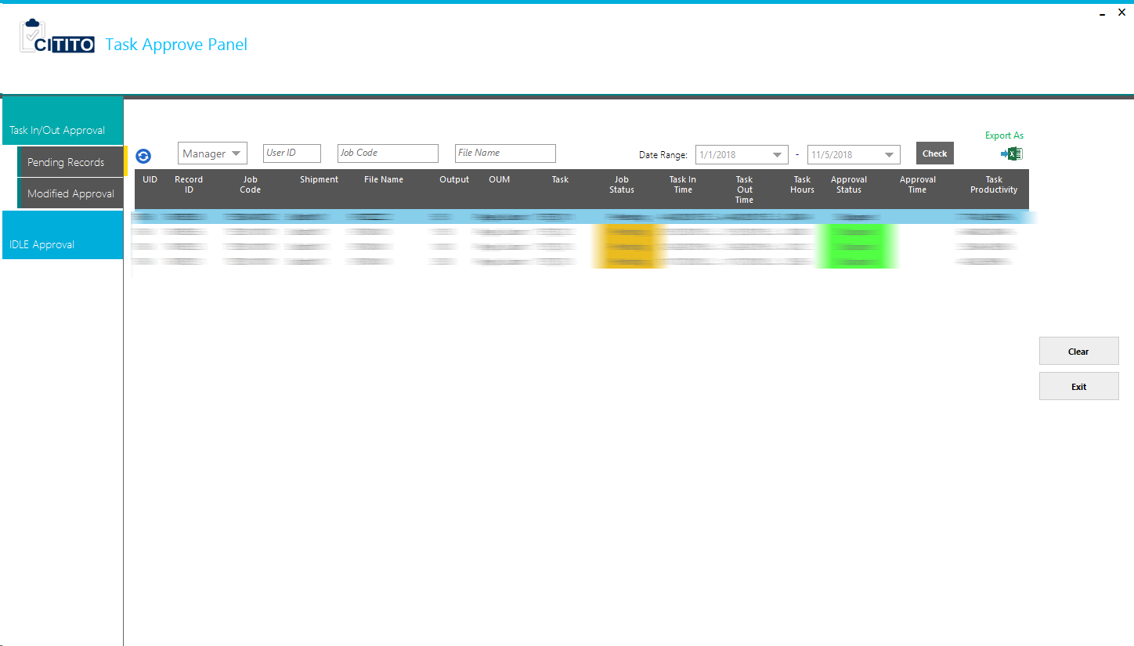

#### 3.4.3.3. Modified Approval

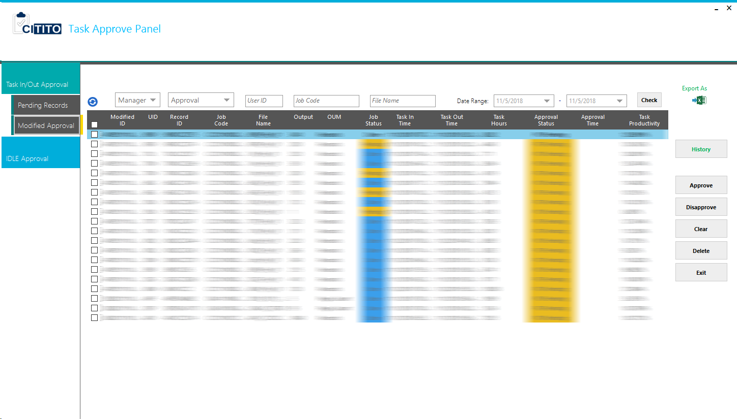If there any conflict on employee task record, manager can be modify task record. The modified task record should approve by the PIC. From this tab PIC can be able to approve modified records by manager.

#### 3.4.3.4. IDLE Approval

All employees’ IDLEs will show on this tab.

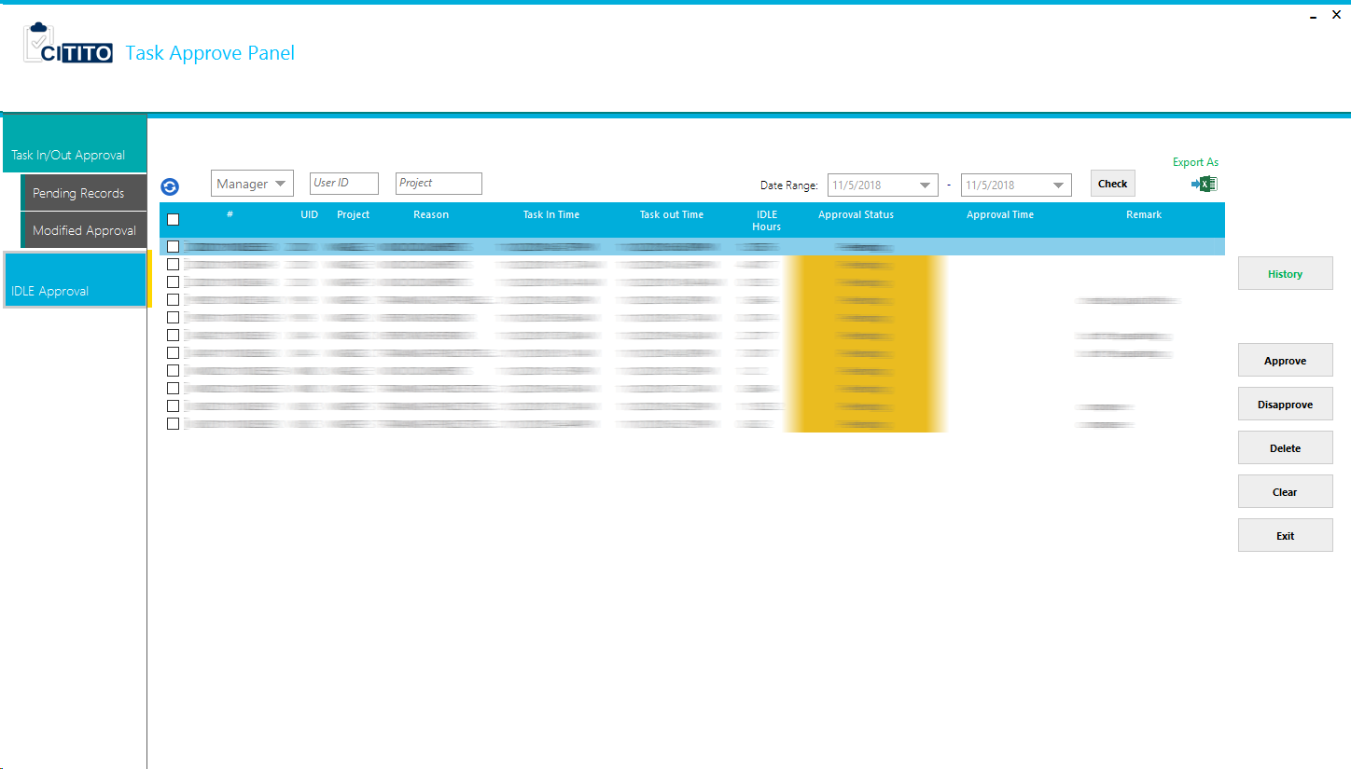

IDLE approval history.

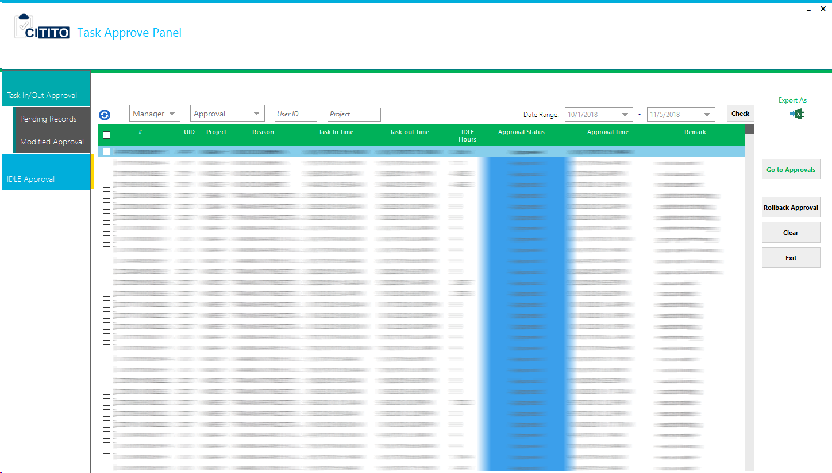

### 3.4.4. Reports

PIC is able to get following reports for future action.

The dashboard is shown,

1. Dashboard
2. Team Details
3. Task & Quota
4. Workload
5. X3 Project
6. X3 Team
7. X3 User
8. X3 User (ProjectWise)
9. X3 Tasks
10. IDLE & Wastage
11. PTR
12. Cost

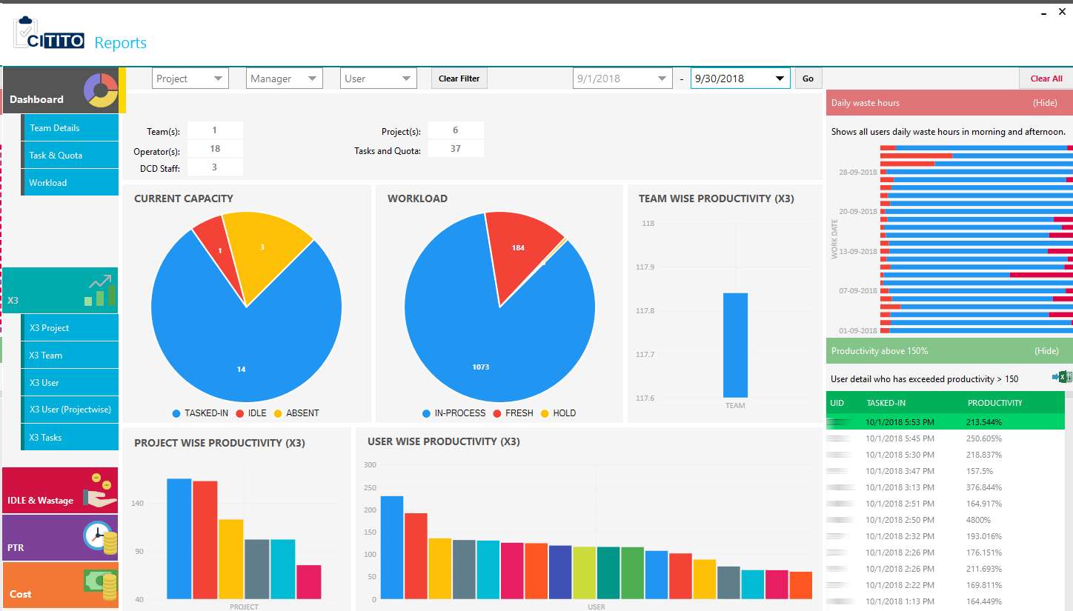

#### 3.4.4.1. Dashboard

Summarized details for PIC is shown in this dashboard. All the data will gather from CITITO database and Global AMS database.

1. Number of Teams
2. Operator Count
3. DCD Staff Count
4. Project Count
5. Registered Tasks & Quota Count
6. Current Capacity
7. Workload
8. Team Wise Productivity (X3)
9. Project Wise Productivity (X3)
10. User Wise Productivity (X3)
11. Daily Waste Hours
12. Productivity above 150%

#### 3.4.4.2. Team Details

Team and user detail under PIC is displaying here. Project and Team Manager Name, Team wise current utilization and current utilized UID will show with Team Details summary.

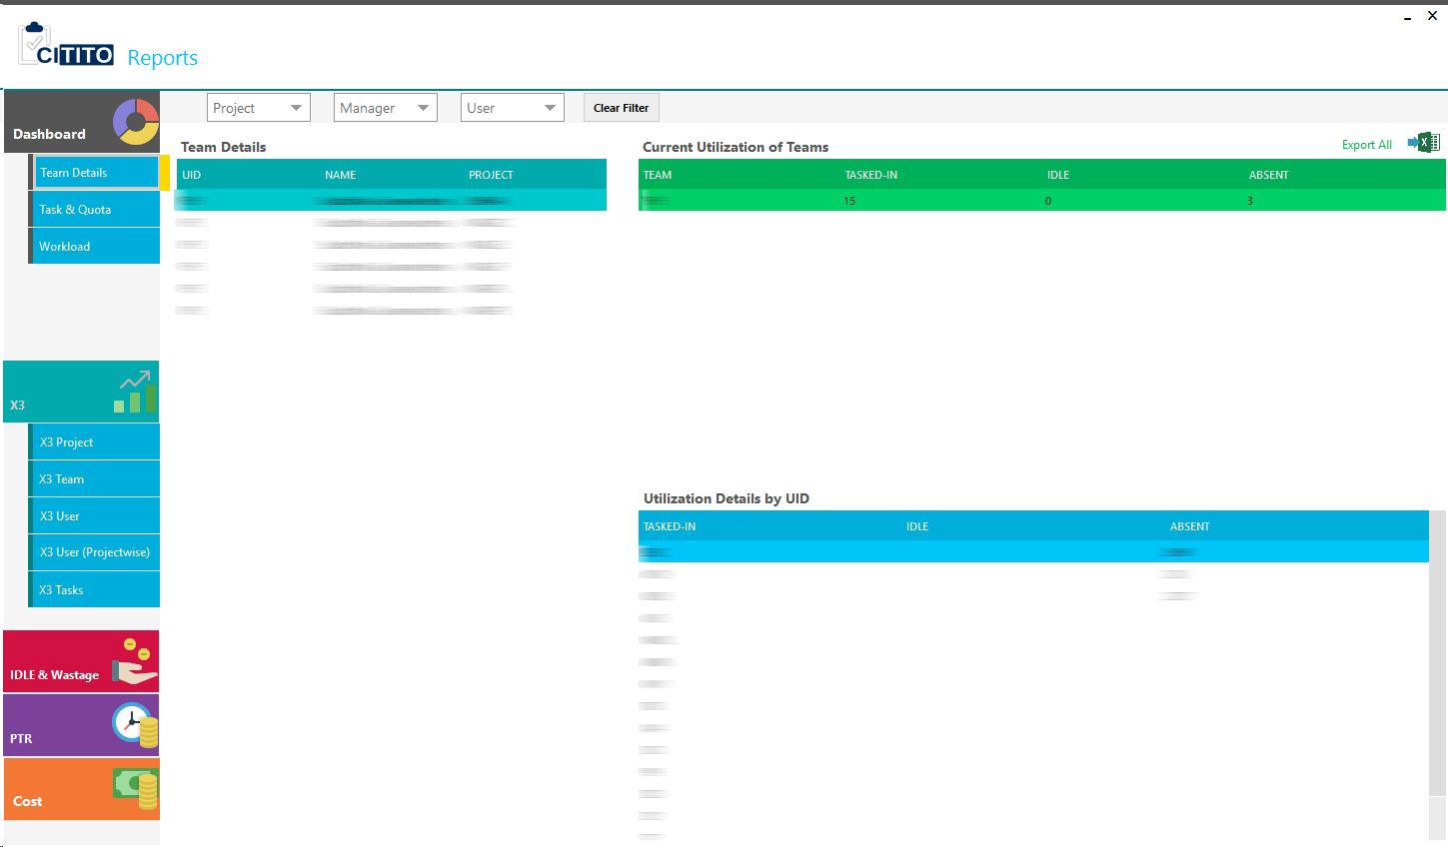

#### 3.4.4.3. Task & Quota

Each and every task wise UOM, Quota, Number of Operators, Average, Highest, Lowest Productivity, Standard deviation and used records will show in Task & Quota review summary. PIC can review their task & quota periodically or real time to make action.

For each record in summary has View records button to check all based on records that make summary.

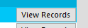

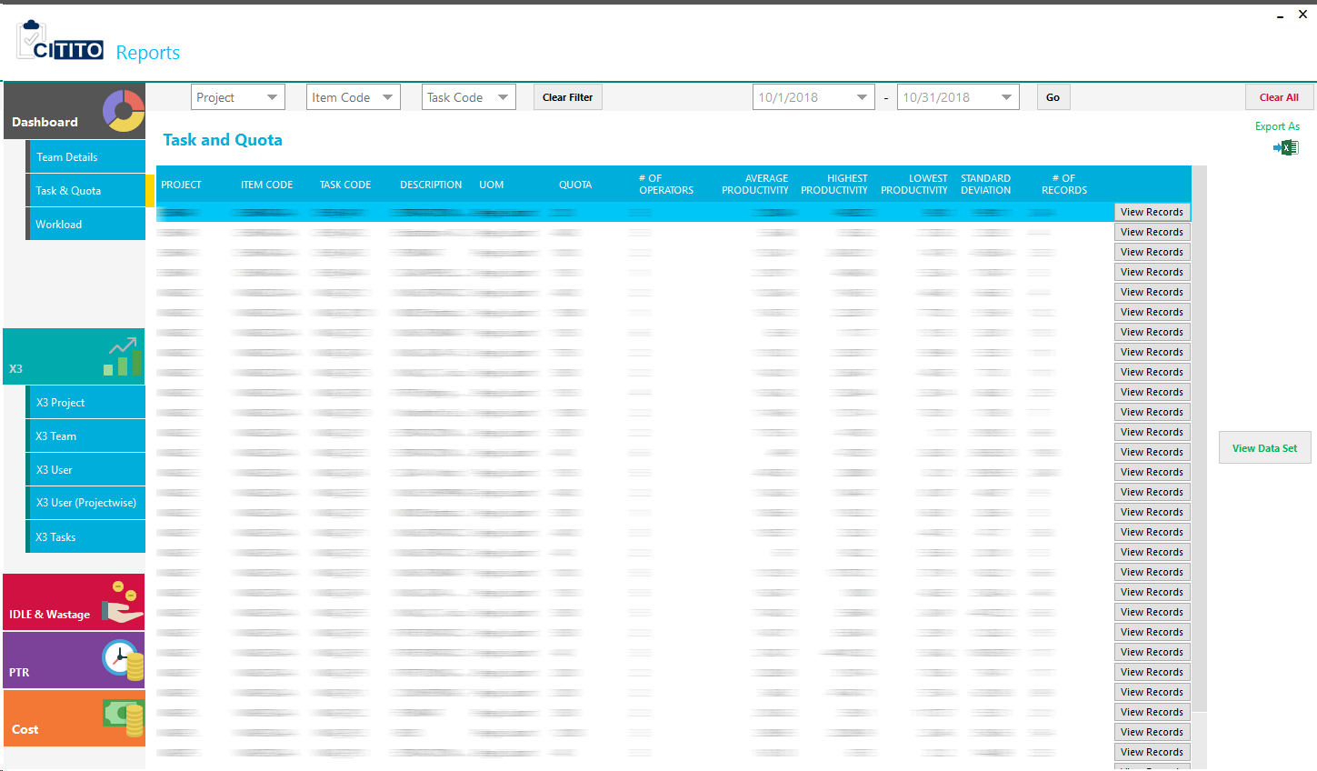Summary:

View Records:

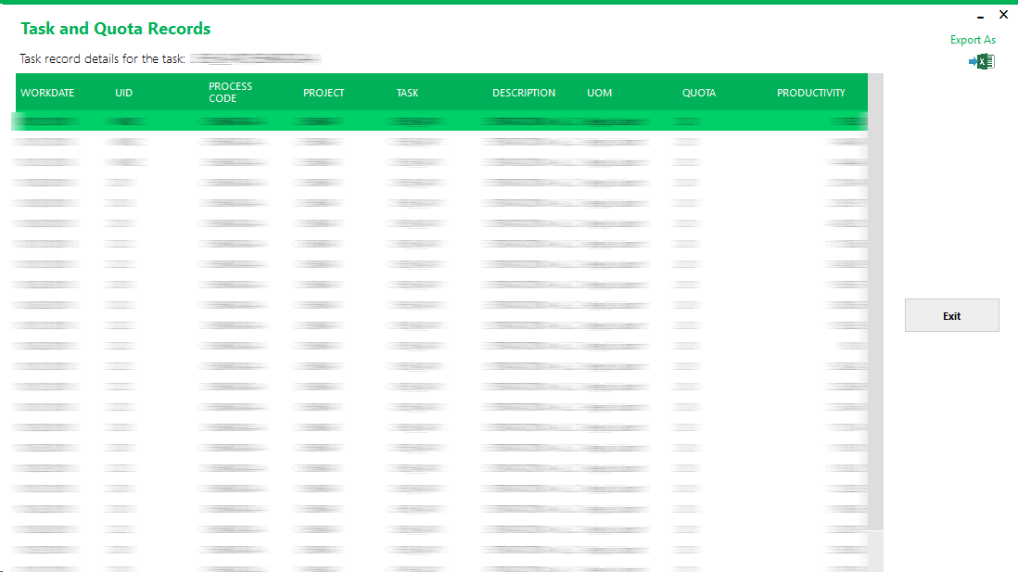

#### 3.4.4.4. Workload

PIC can review project wise all the Registered, Completed, In Process, Fresh and Hold Volumes.

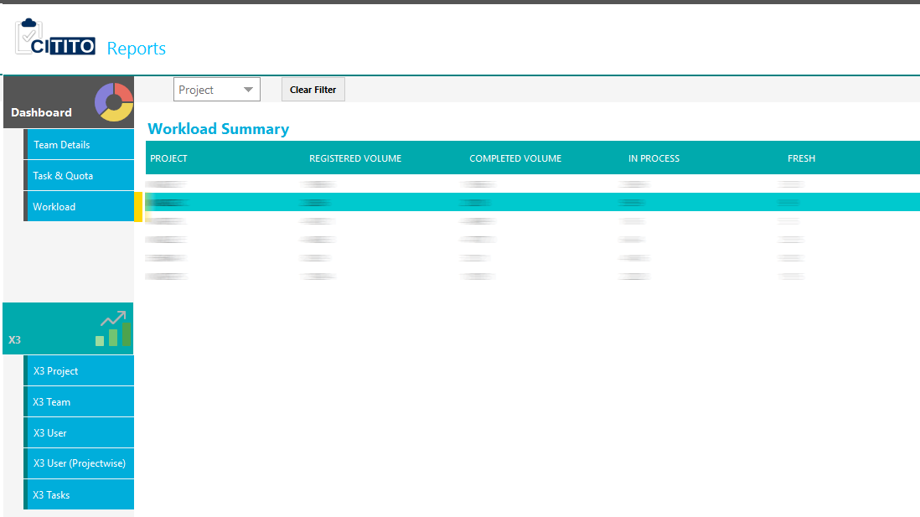

By clicking “View Data Set” all the records can be refer individual status.

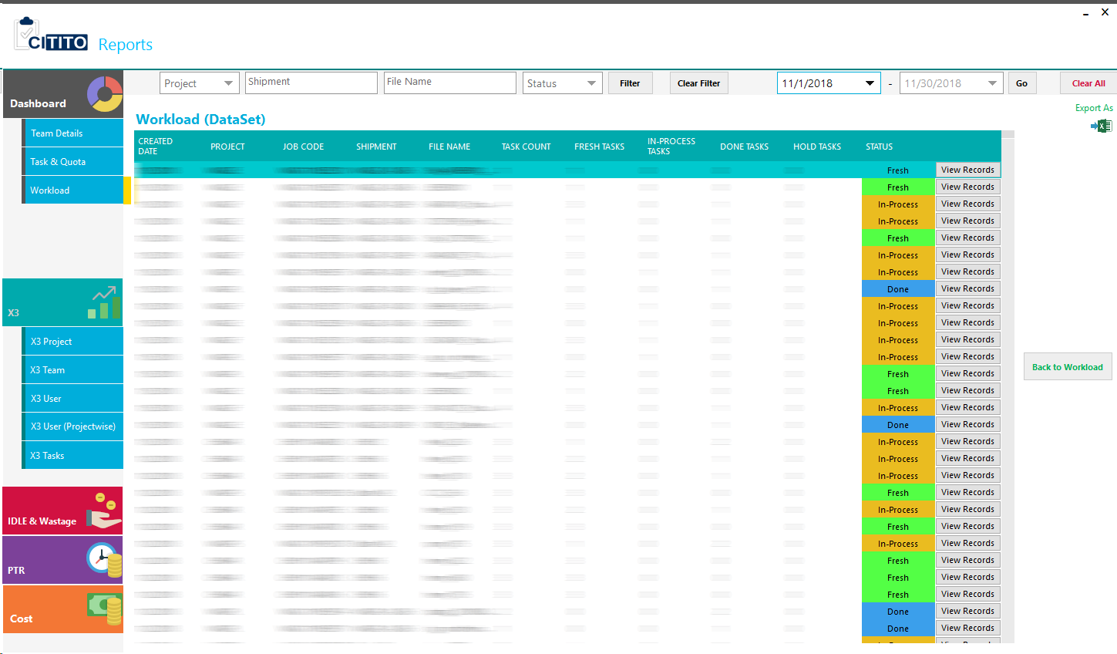

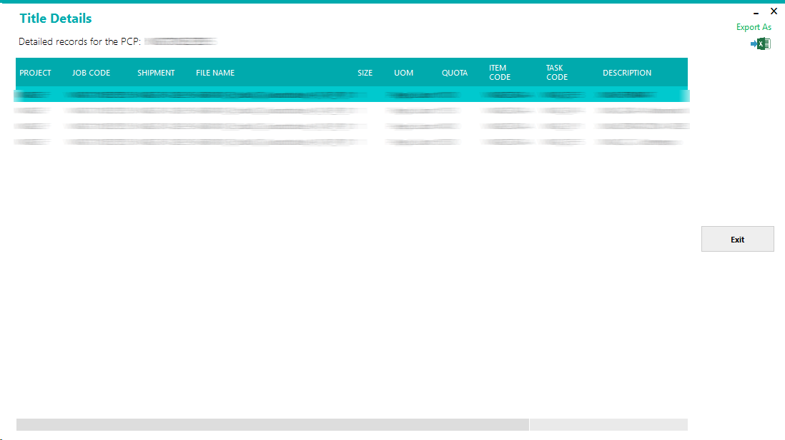

#### 3.4.4.5. X3 Project

Each project wise performance is showing X3 Project tab.

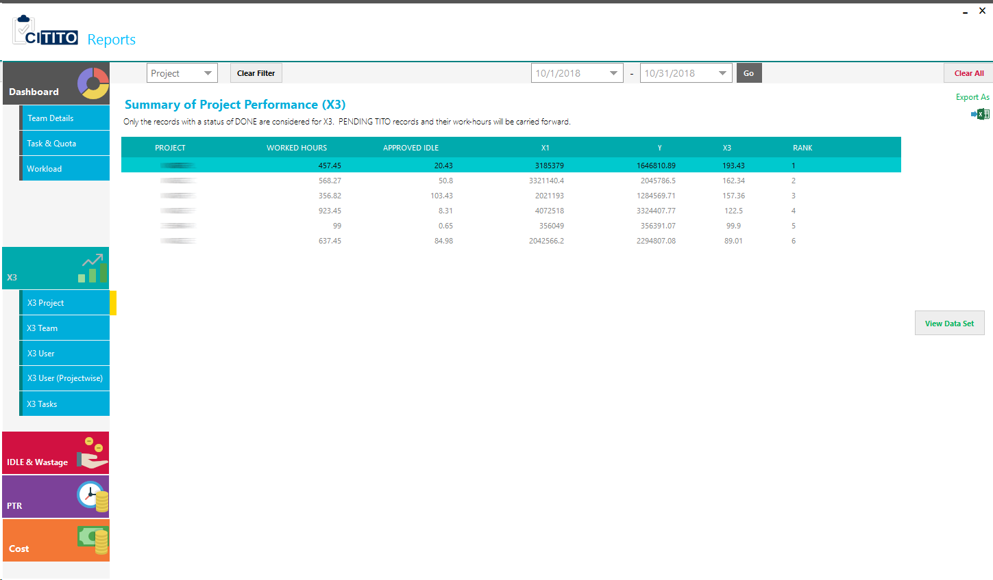

#### 3.4.4.6. X3 Team

PIC owned team wise performance will show here.

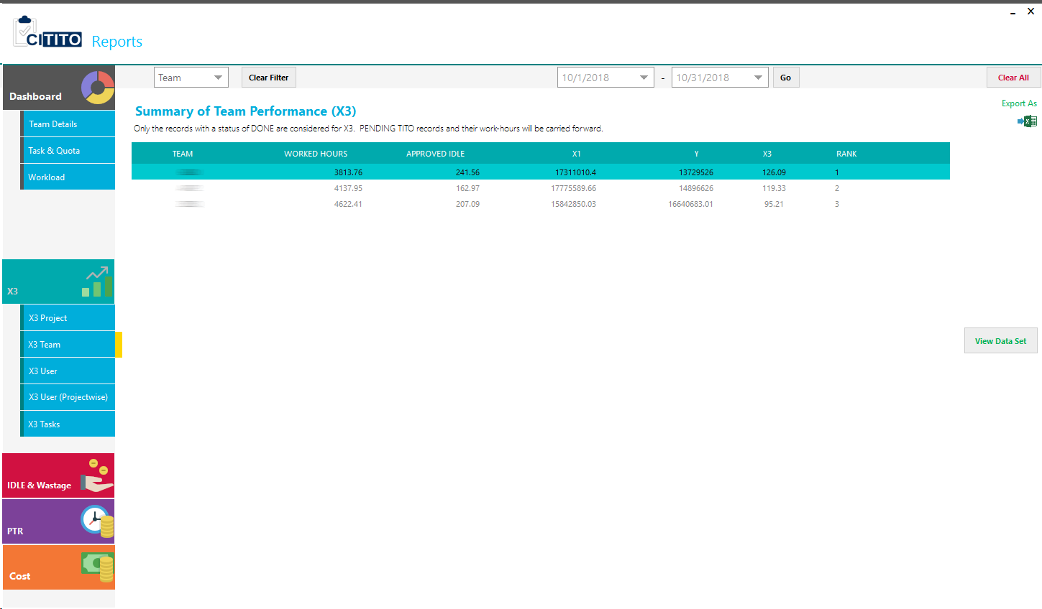

#### 3.4.4.7. X3 User

All the user performance under PIC will show X3 User tab.

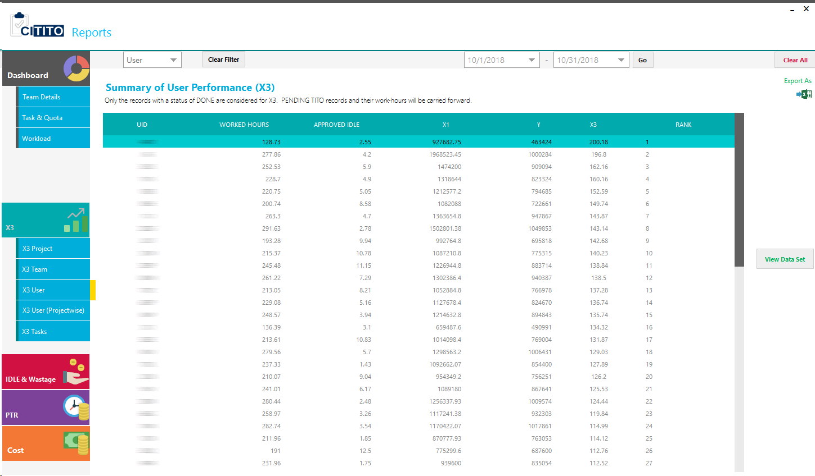

#### 3.4.4.8. X3 User (ProjectWise)

Every employee project wise performance will show here.

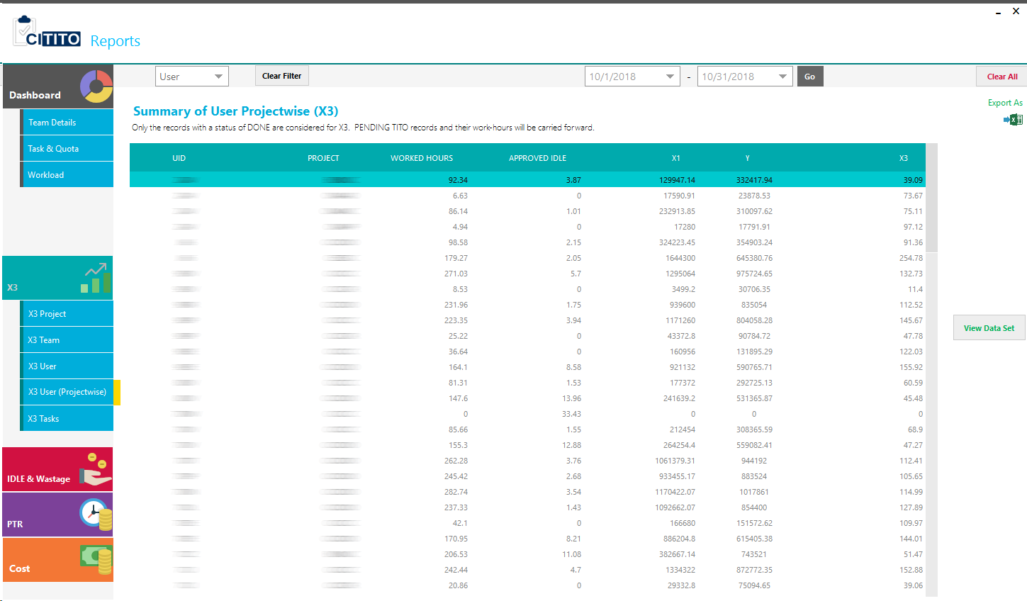

#### 3.4.4.9. X3 Tasks

Task wise performance in each project will show here.

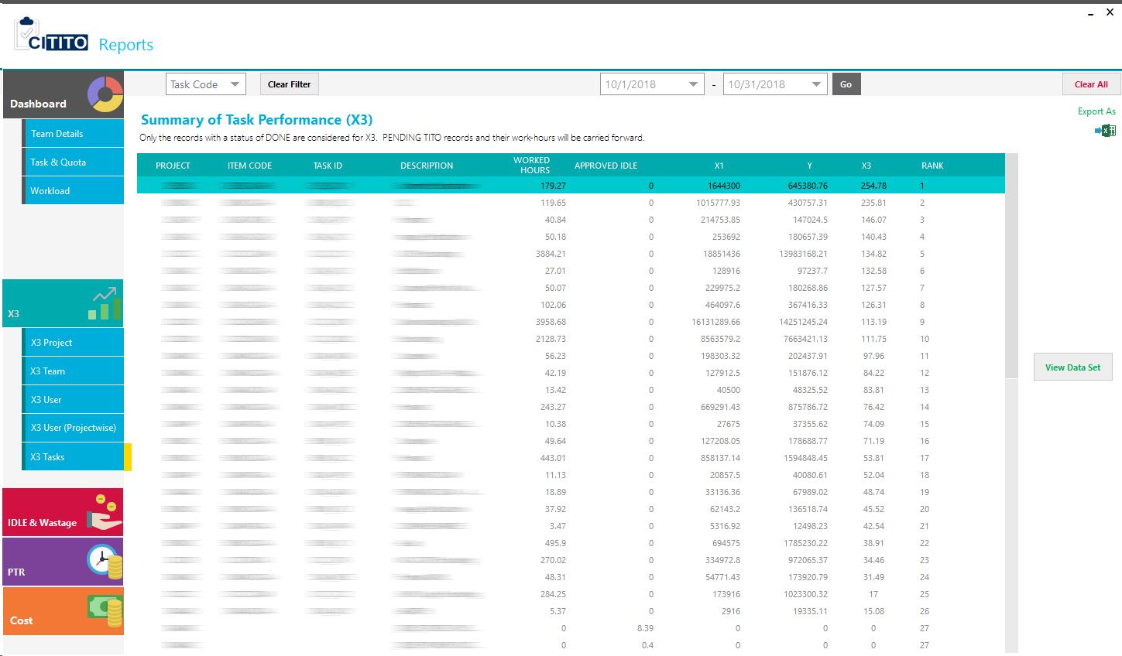

**Note:** For all of X3 tabs have a function to view Dataset of each task records. PIC can get all the records by clicking “View Data Set” button. These records have only task records without IDLE and waste time.

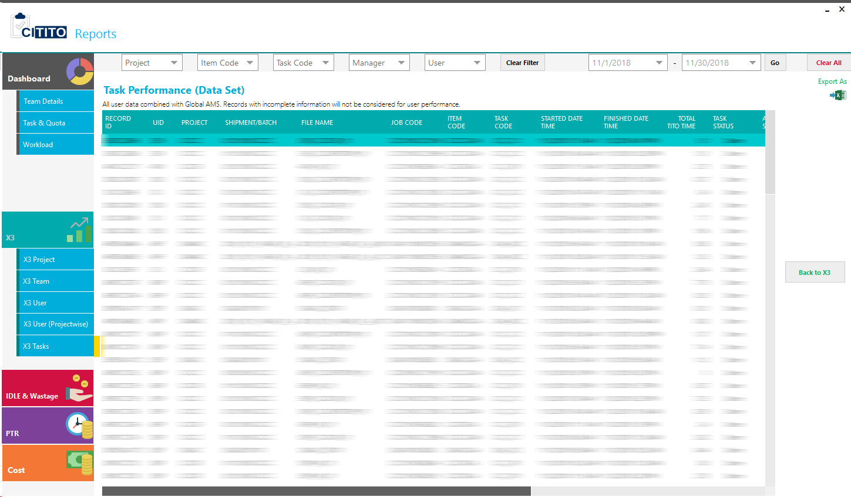

#### 3.4.4.10. IDLE & Wastage

PIC can review each user IDLE and waste hours, capacity utilization, and total AMS and TITO hours from here.

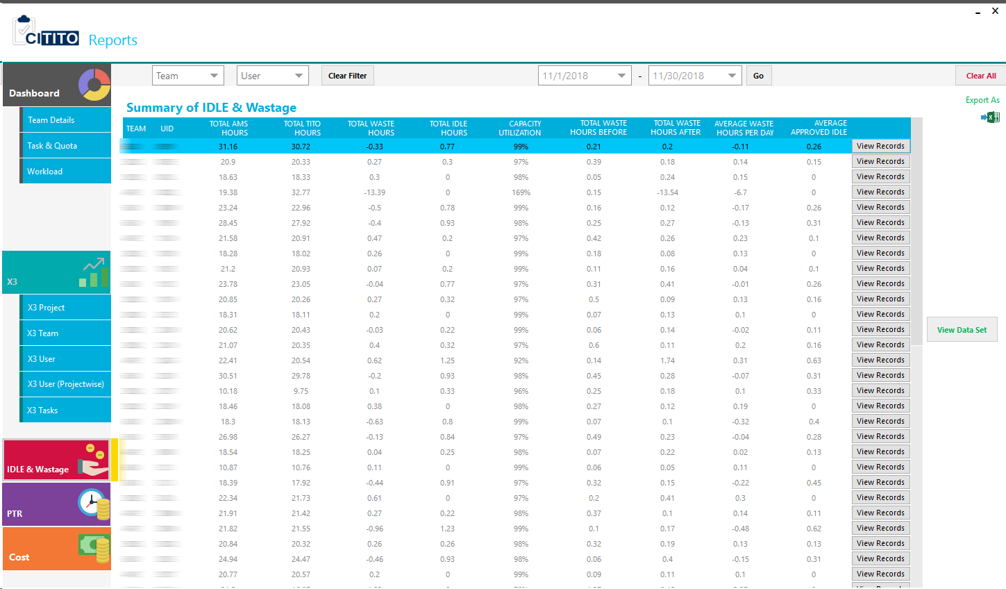

#### 3.4.4.11. PTR

Monthly PTR can be generated from here. PIC is responsible to generate PTR from CITITO.

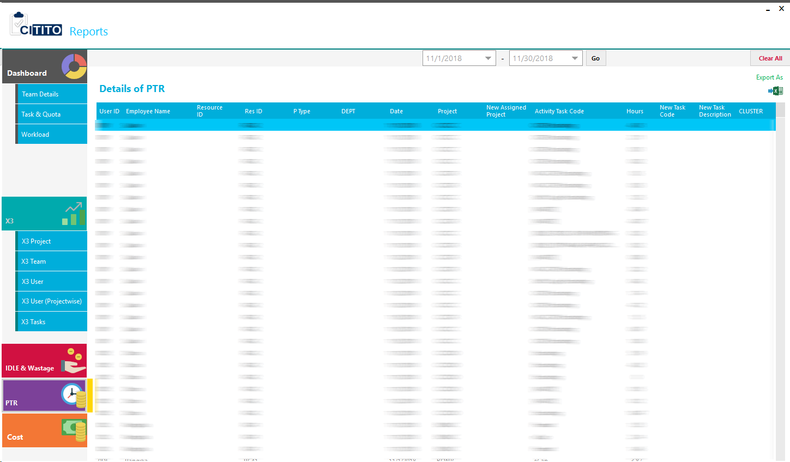

#### 3.4.4.12. Cost

Monthly cost by each project will show in here.

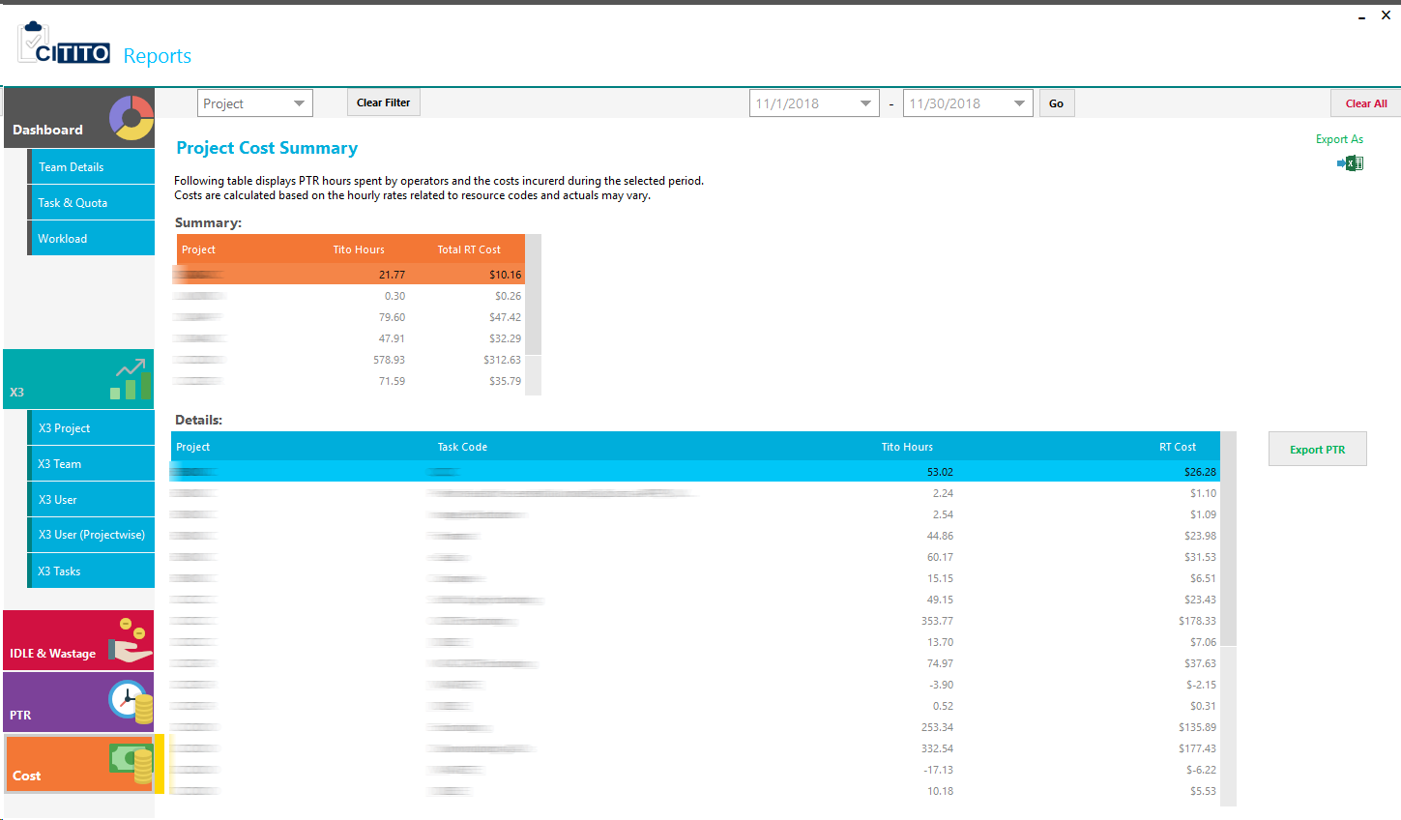

## 3.5. Immediate Manager Panel

Once manager logged in to the system, they will prompt following window with relevant functions. The functions are,

1. User Registration
2. Task Approval
3. Reports

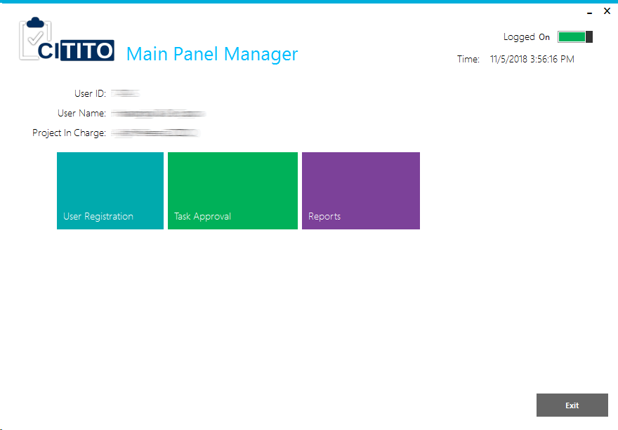

### 3.5.1. User Registration

From this window manager can register their team mates with CITITO. All the users registered by manager are “Common Users”, they could be able to Task In/Out. To register any user to the system, manager has to know about salary scale or Resource ID of relevant user.

There is a required area to fill user Shift also. As an example shift details can be extracted from Global AMS.

Project field automatically filled up when projects assigned by PIC. If manager need to assign new project to a user, the manager need to get registered under relevant project.

User modification allows to change registered user 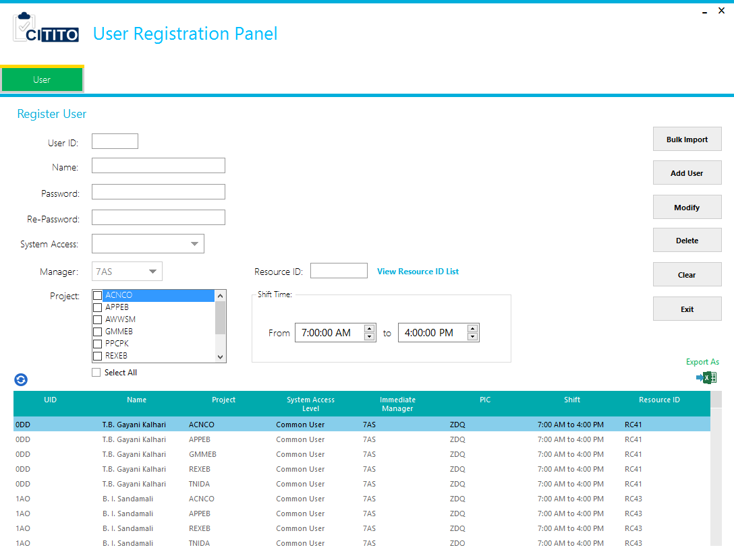Basic Details and Project Details.

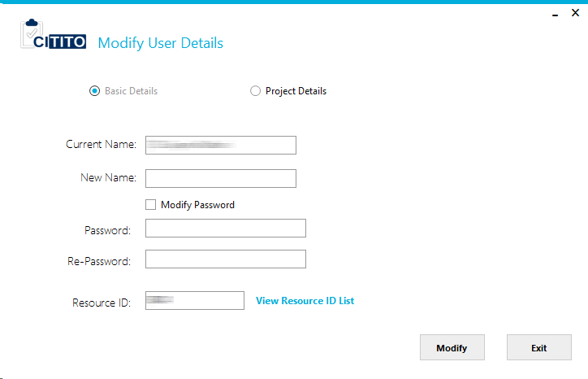

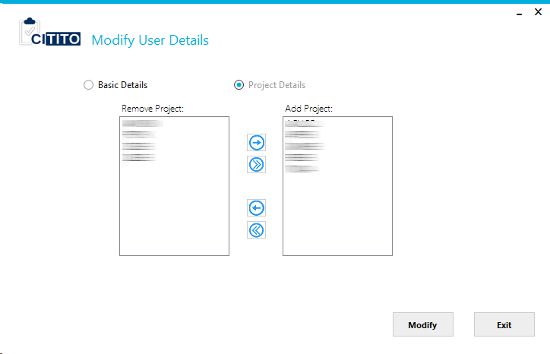

### 3.5.2. Task Approval

User task/Idle records approval, disapproval and modification can be done from this module. Manager is responsible to check and confirm user task records are correct or not. Following functions are available for the manager:

1. Task In/Out Approval
2. Pending Records
3. Modified Records
4. 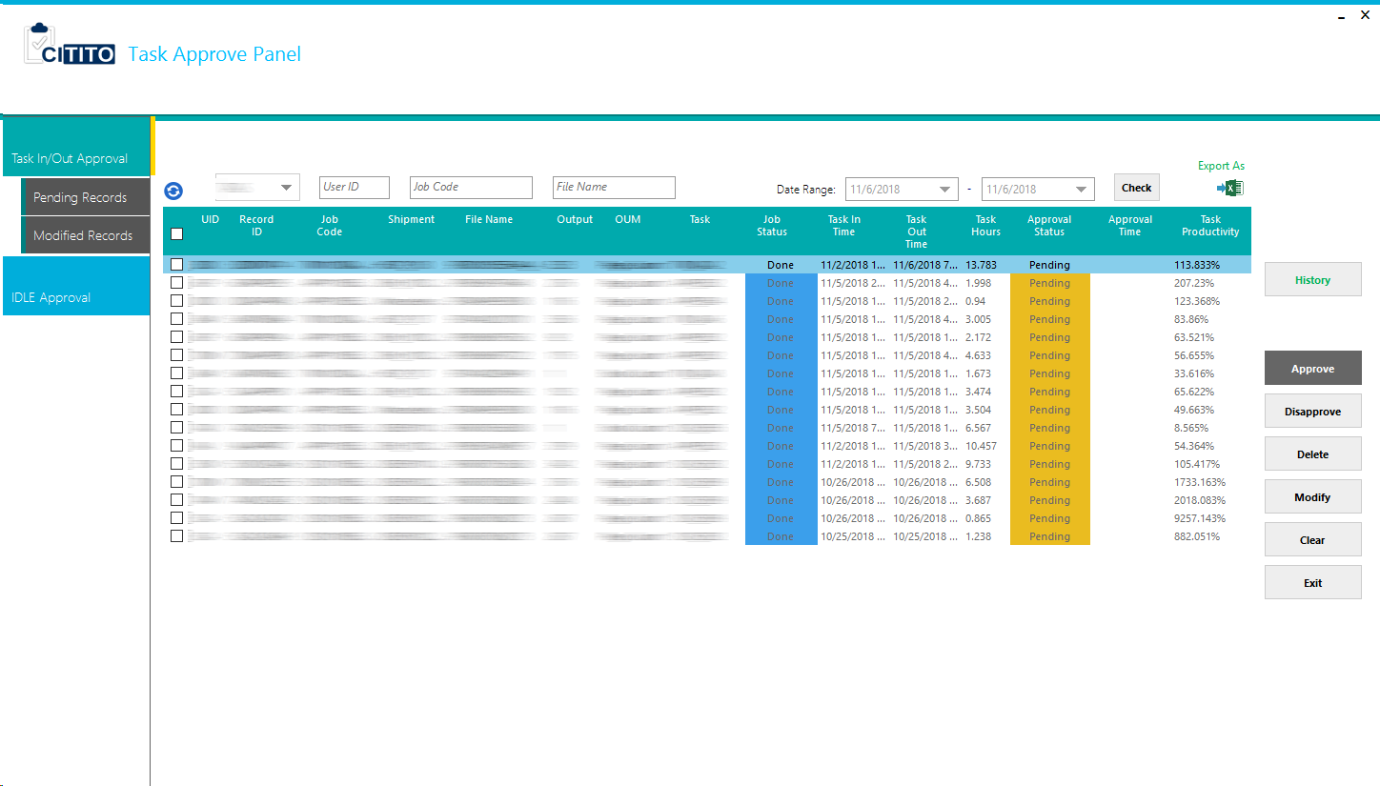IDLE Approval

#### 3.5.2.1. Task In/Out Approval

In this window manager able to approve/disapprove user tasks, modify task record and delete a task record. All the done status records will show in here with pending approvals.

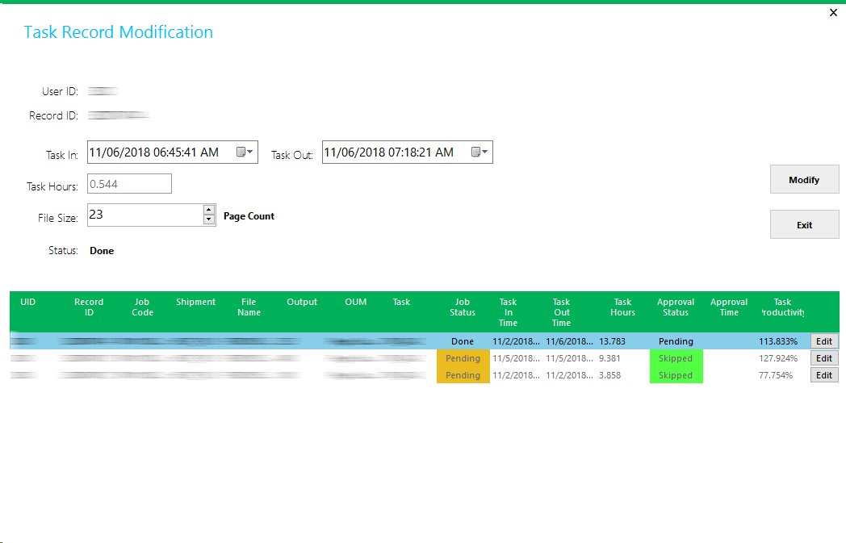Modify task record is weighted function in this task approval window. Manager is responsible to modify any task record from this function. Once modified any task record, it should be get approval by PIC. The PIC approved task record is overwrite the user actual task record.

#### 3.5.2.2. Pending Records

This function is given to check all employees’ pending task records. It was given only for reference and not enable any function to approvals.

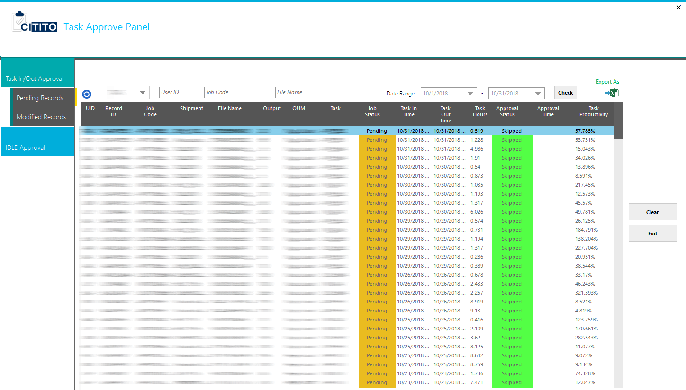

#### 3.5.2.3. Modified Records

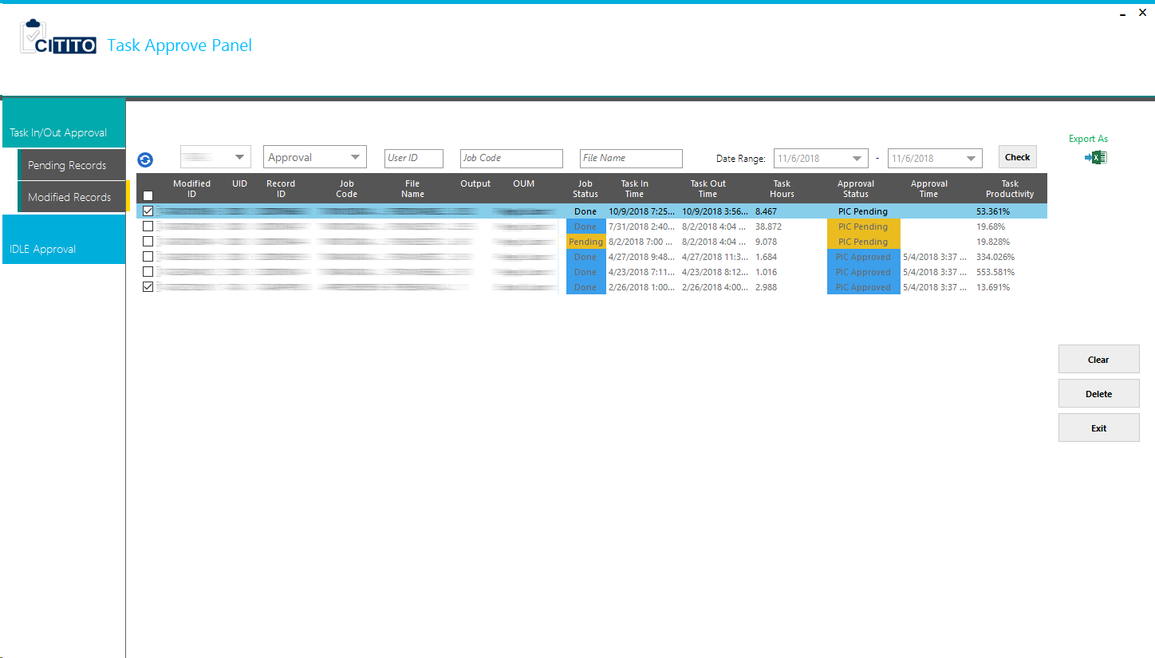Modified record history will display here. Manager need to be get approvals from PIC to overwrite user task records otherwise it will show approval status as “PIC Pending”

#### 3.5.2.4. IDLE Approval

All employees’ IDLE records will show on this tab.



### 3.5.3. Reports

Manager will able to get following reports for future action.

The dashboard is shown,

1. Dashboard
2. Team Details
3. Workload
4. X3 Project
5. X3 Team
6. X3 User
7. X3 User (ProjectWise)
8. X3 Tasks
9. IDLE & Wastage

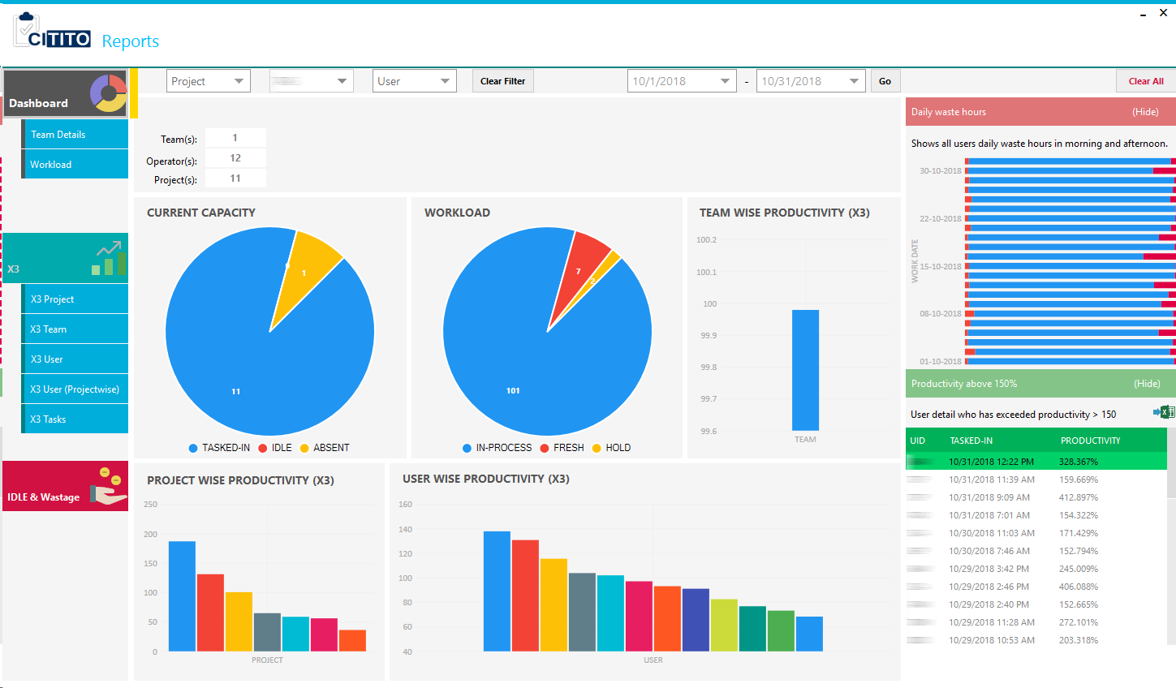

#### 3.5.3.1. Dashboard

Summarized details for Manager, is shown in this dashboard. All the data will gather from CITITO database and Global AMS database.

1. Number of Teams
2. Operator Count
3. Project Count
4. Current Capacity
5. Workload
6. Team Wise Productivity (X3)
7. Project Wise Productivity (X3)
8. User Wise Productivity (X3)
9. Daily Waste Hours
10. Productivity above 150%

#### 3.5.3.2. Team Details

User detail under the manager is displaying here. Project and manager name, current utilization and current utilized UID will show with Team Details summary.

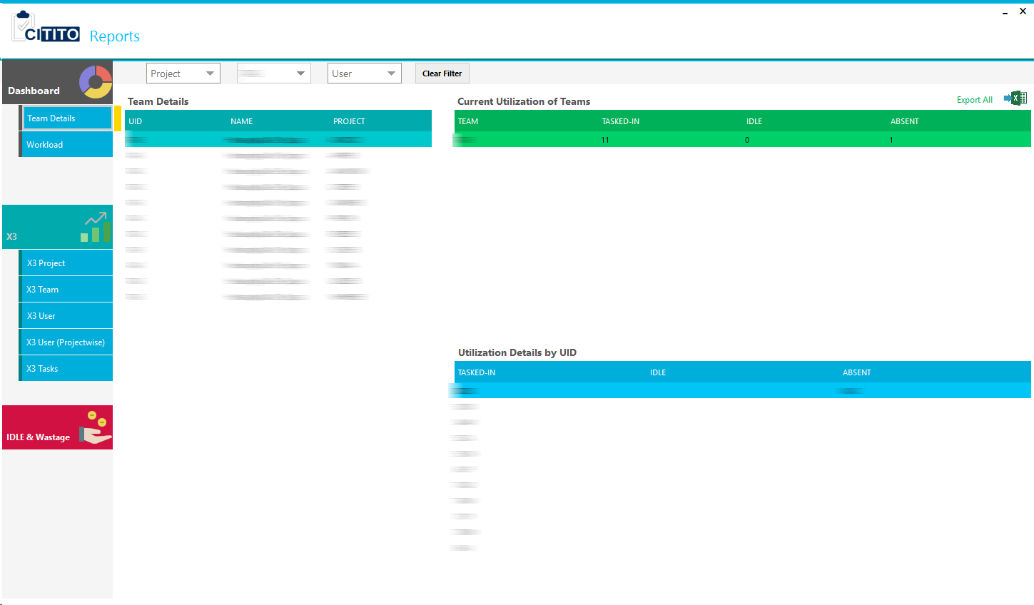

#### 3.5.3.3. Workload

Manager can review project wise all the Registered, Completed, In Process, Fresh and Hold Volumes.

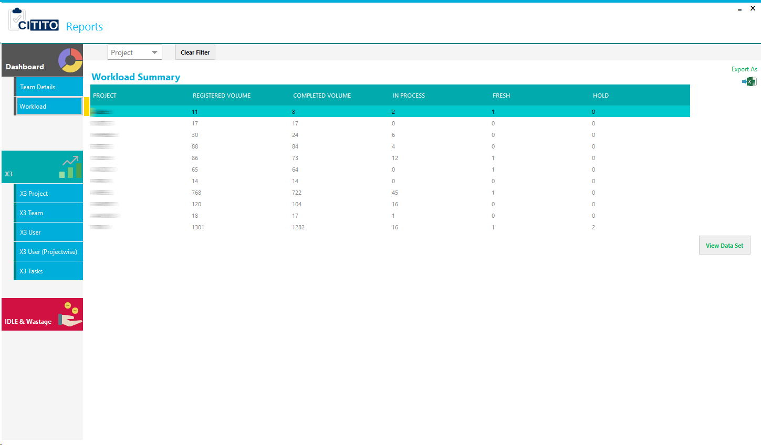

#### 3.5.3.4. X3 Project

Each project wise performance is showing X3 Project tab

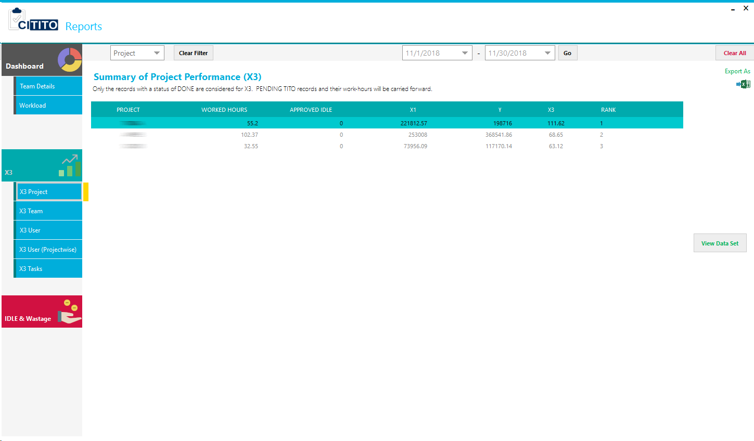

#### 3.5.3.5. X3 Team

Manager owned team performance will show here.

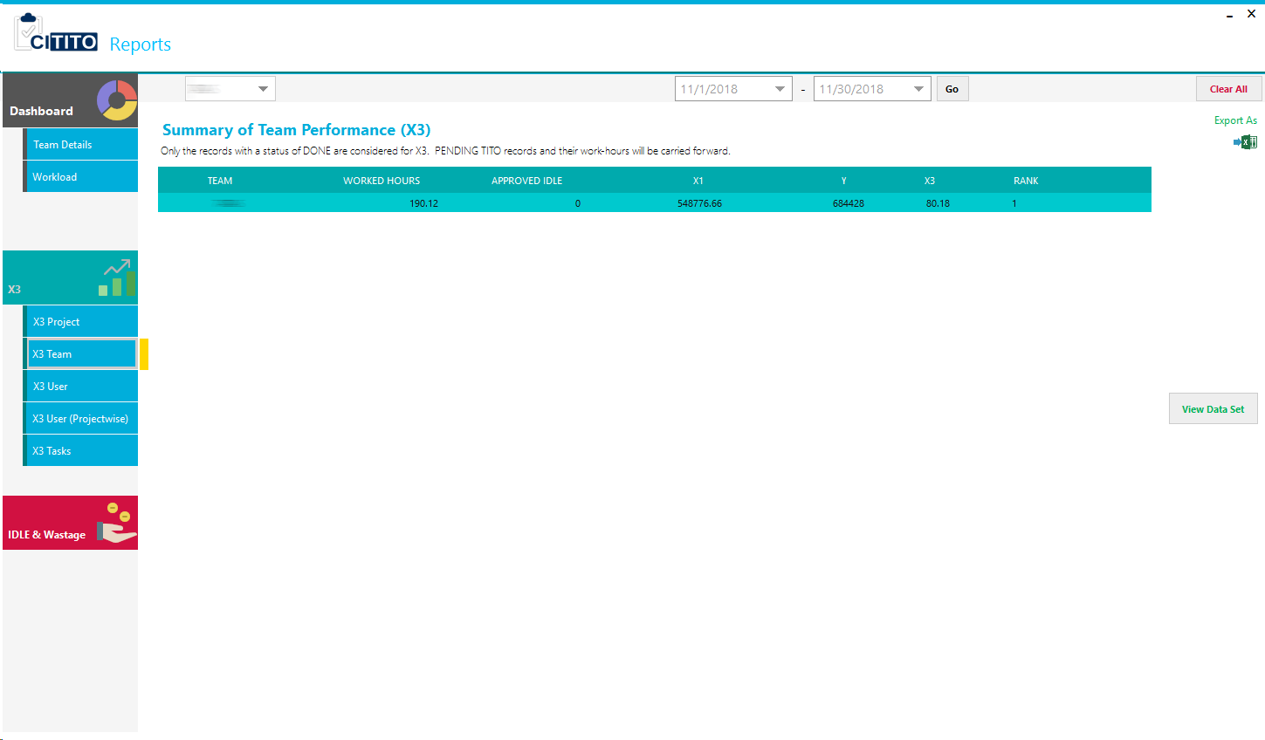

#### 3.5.3.6. X3 User

All the user performance under the Manager will show X3 User tab.

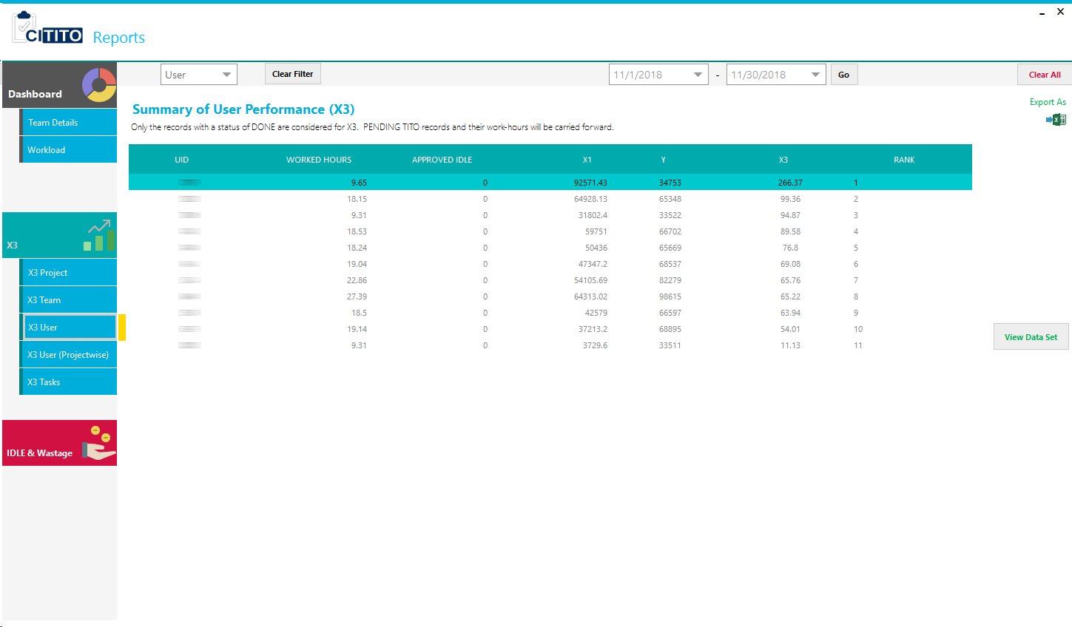

#### 3.5.3.7. X3 User (ProjectWise)

Every employee project wise performance will show here.

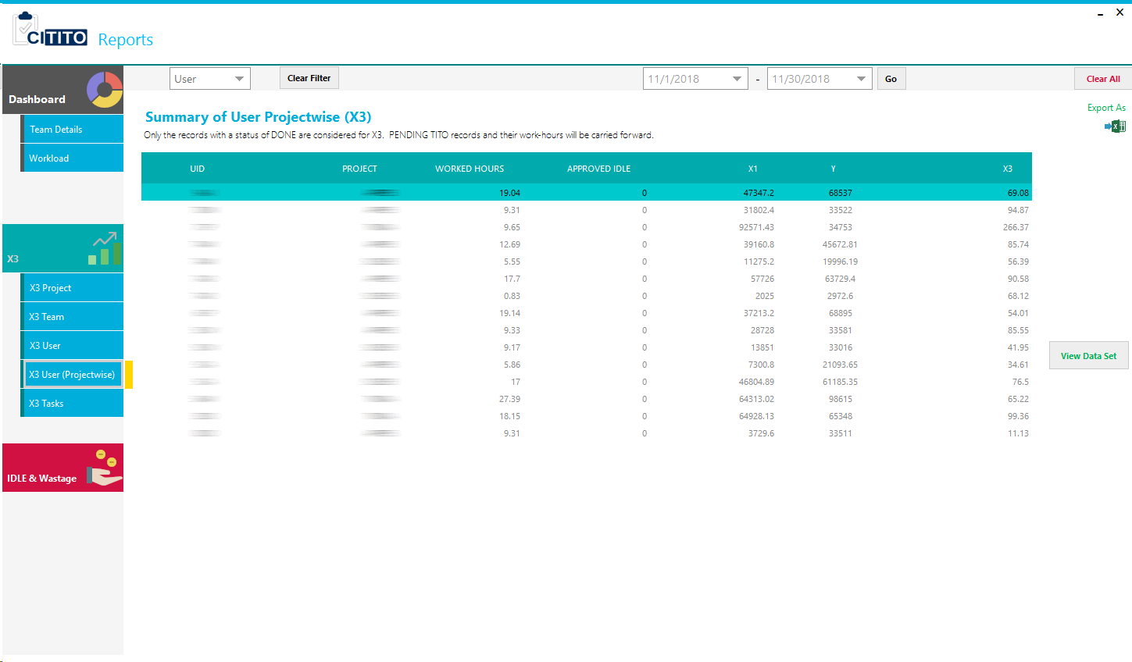

#### 3.5.3.8. X3 Tasks

Task wise performance in each project will show here.

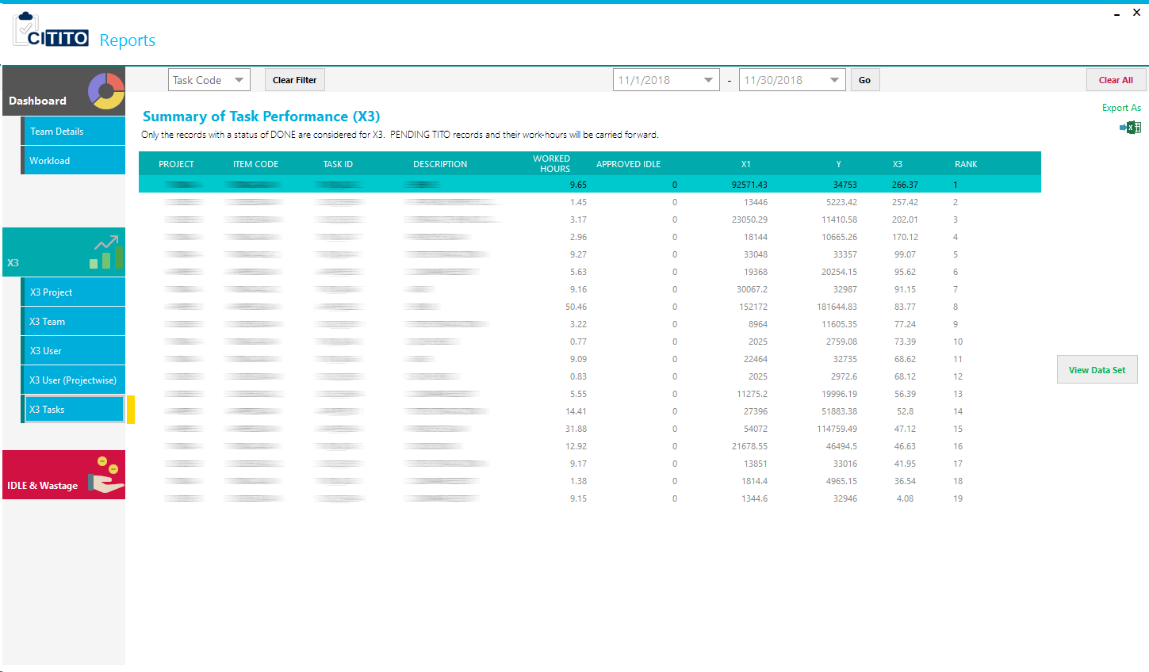

**Note:** For all of X3 tabs have a function to view Dataset of each task records. PIC can get all the records by clicking “View Data Set” button. These records have only task records without IDLE and waste time.

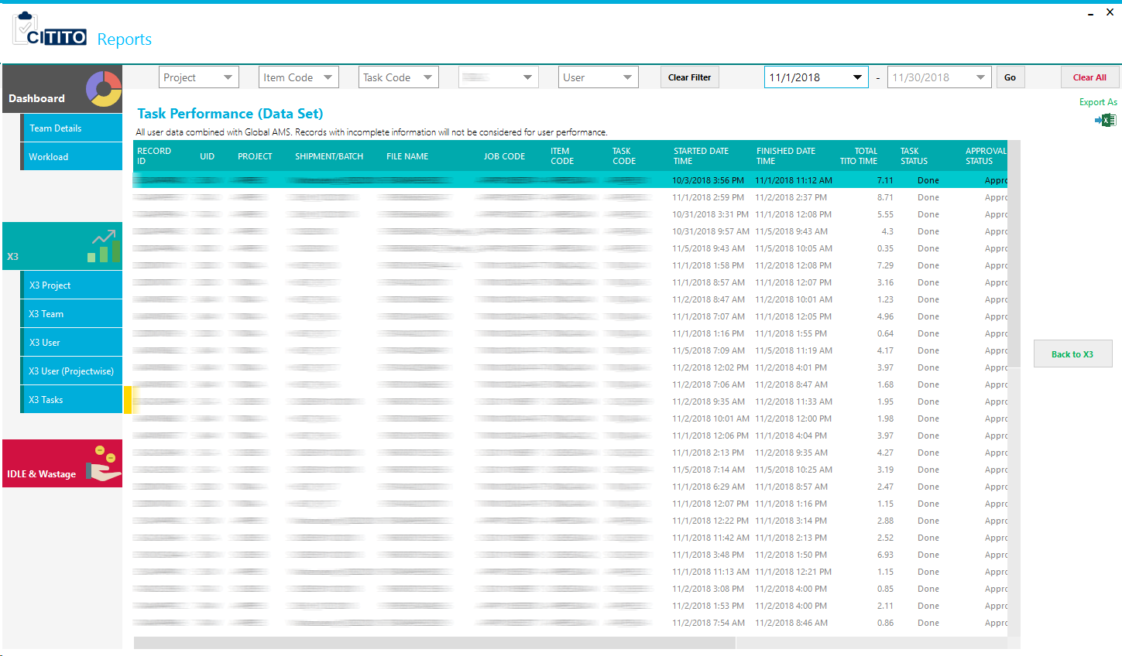

#### 3.5.3.9. IDLE & Wastage

Manager can review each user IDLE and waste hours, capacity utilization, and total AMS and TITO hours from here.

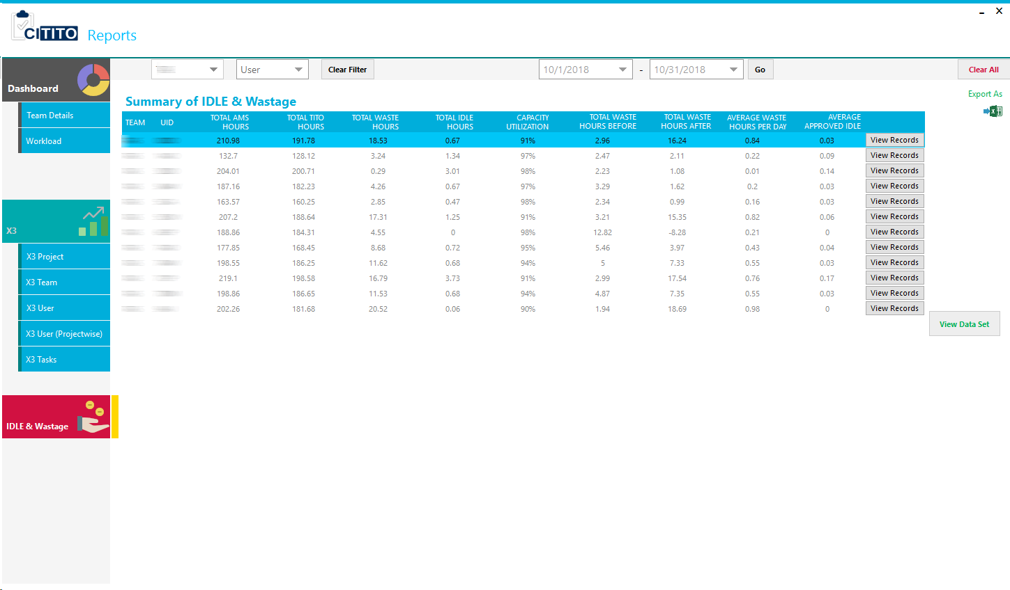

**View Record** function in each record will show all based records to the summary.

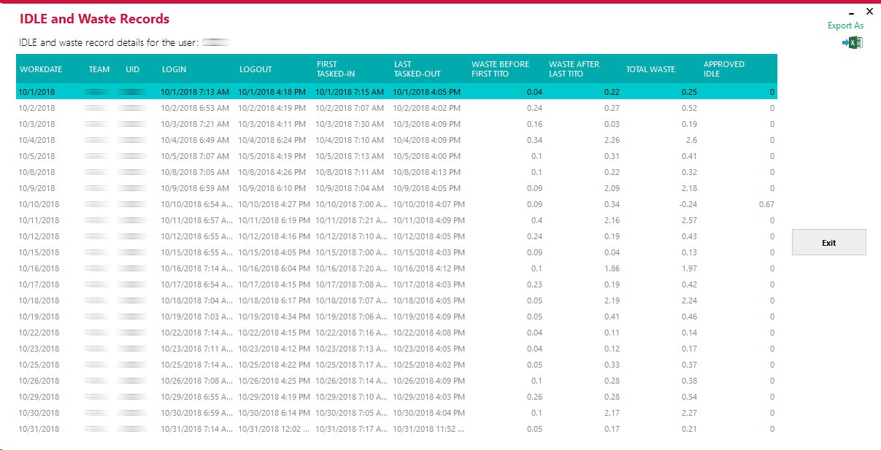

## 3.6. DCD Panel

All the job registration part will be done by DCD member. Once PIC create and assign projects to the DCD member, DCD account owner responsible to make jobs to the production.

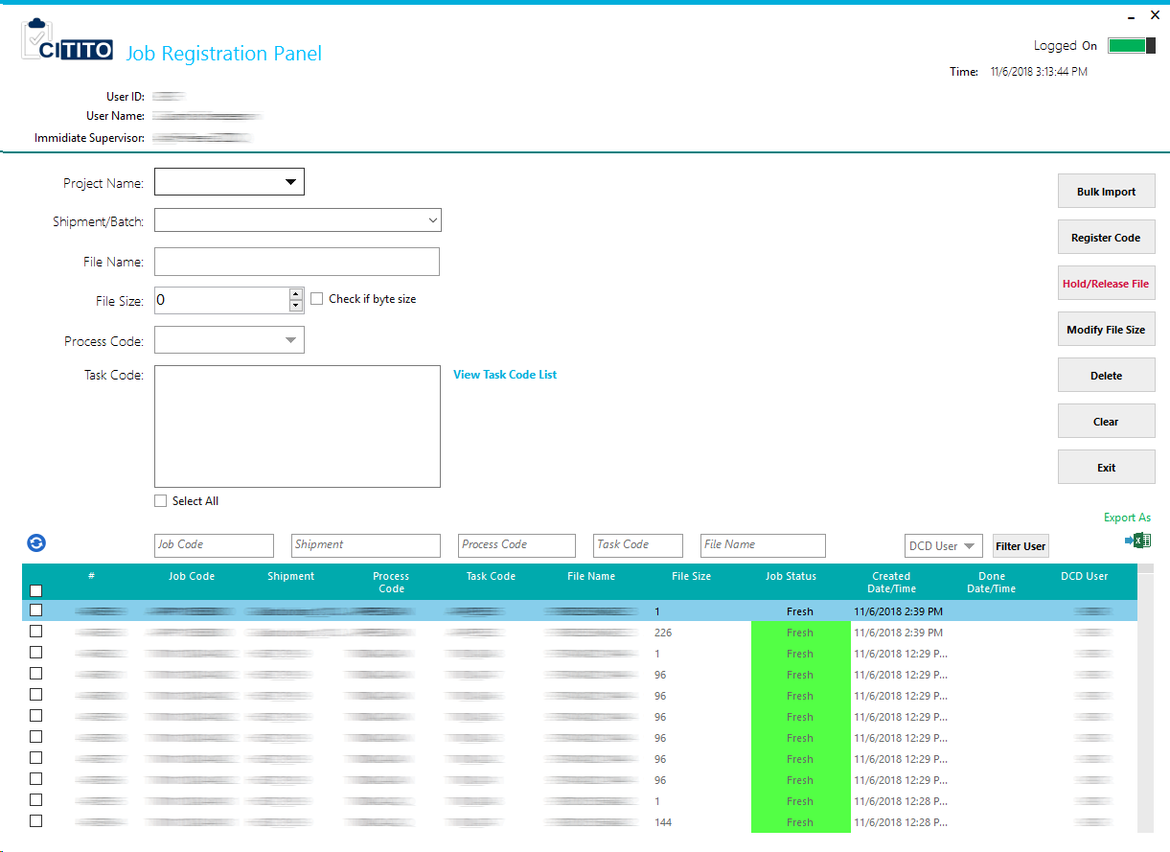

In advance, DCD user can take bulk import function to register job code as once. Template is structure as given below.

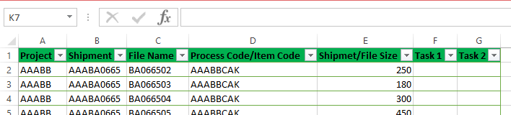

DCD user mush be fill Project, Shipmen, Filename, Item Code, File Size and Task Codes (CITITO registered). Once template is prepared correctly, DCD user can use following import window by clicking Bulk Import button.

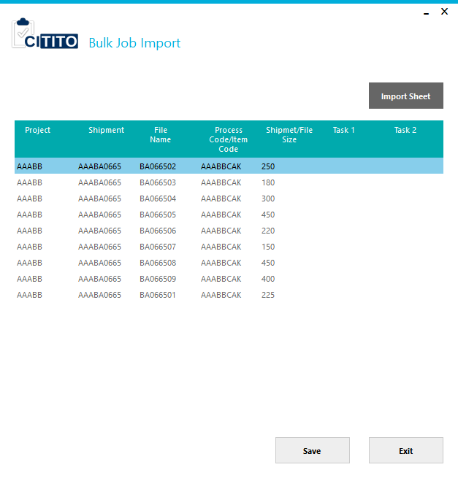

Deletion can do on record by record. Make sure only the fresh status record can be deleted.

Modify option given for file size modification only for fresh and pending status records.

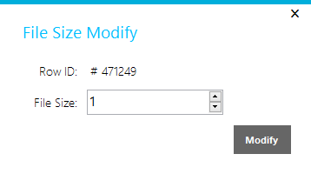

Additionally DCD user can keep hold or release file using “Hold/Release File” button.

## 3.7. Employee Panel (Task In/Out)

This is the window that all the common users are using to record their tasks and IDLEs. It always execute on a time based scenario. If user tasked in to job it automatically locked the task and run task time until user tasked out.

Before user task in to the job, he/she have both Shipment Name and File Name or Job Code (TITO Code).

For each and every task record generates Task Productivity, it may help to measure users’ attention/productivity to the relevant task. Task Productivity calculation is:

$$Task Productivity \%=\left(\frac{Output}{Quota}×\frac{9}{Task Time}\right) ×100$$

**Note:** For manual calculation, template has been placed on source path called “Manual Calculation X3”. This only for task productivity, for the final X3, it will add waste and IDLE hour records. Shift time taken as 9 hours and instruct PICs to update all the matrixes for 9hours quota.

User task panel have three tabs called,

1. Task In/Out
2. IDLE
3. X3 Performance

### 3.7.1. Task In/Out

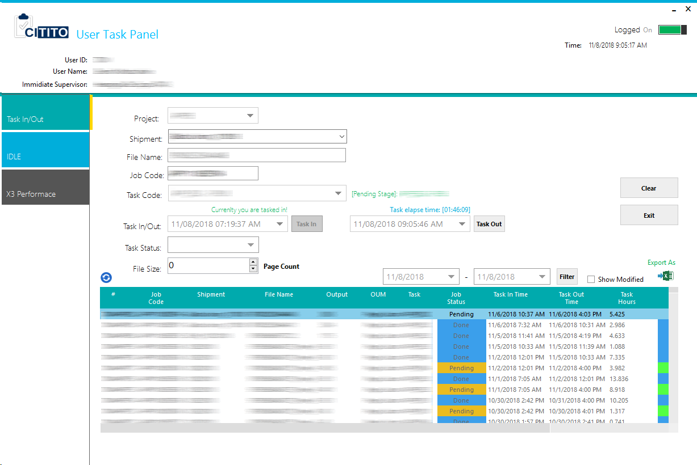Commonly this tab is shown to task in and out for the user. This is the default window once common user is logged in to CITITO system. Only done status approved task records will nominate to the X3.

“**Show Modified**” check box is given to retrieve modified task records by manager. Record ID will highlight if it is modified.

### 3.7.2. IDLE

User can apply their IDLE records to CITITO from here. IDLE records creation is restricted to 5 days maximum and freely available time span (not tasked in period within AMS hours).

IDLE remark is restricted to maximum 20 characters. Only approved IDLE will nominate to the User X3.

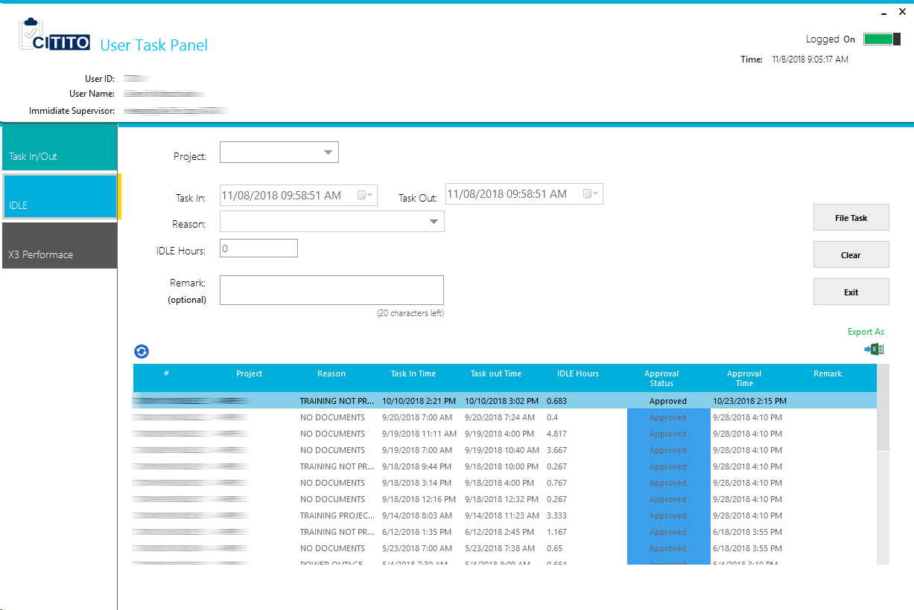

### 3.7.3. X3 performance

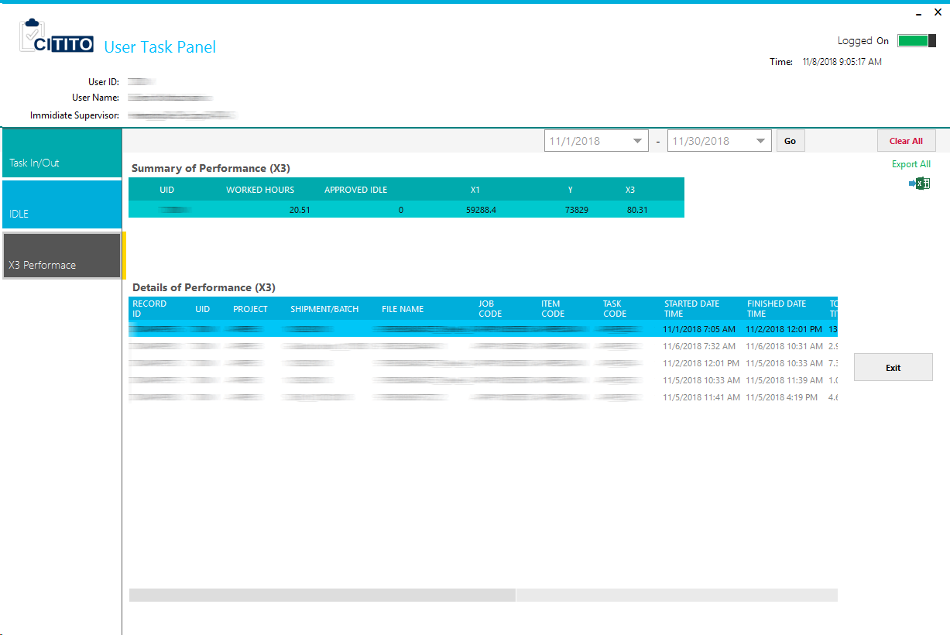As a report module, user X3 performance will show in this tab. User will able to refer their performance individually.

# 4. Implementation

The Implementation phase is that software turn into executable. In this phase software is developed affording to the detail design based on the requirements. C# also is an object oriented language has selected as a programming language to develop the CITITO.

## 4.1. Code Features

3-tier architecture was used in this system. Following is shows blend of three layers.

### 4.1.1. Insert, Update, Delete Data

Following code snippets shows how insertion and updating is happened simultaneously in one button click. Note that full codes are not showing because of the space limit. Code has been taken from user registration Add User function.

//Sample Code…

if (new UserManagementHeaderMng(conn).UserIsExistWithInactive(txtUID.Text.ToUpper()))

{

//Create Object From User

UserManagementHeader mUserManagementHeader = new UserManagementHeader();

UserManagementDetail mUserManagementDetail = new UserManagementDetail();

using (MD5 md5Hash = MD5.Create())

{

// Assign User Header

mUserManagementHeader.P_UID = txtUID.Text.ToUpper();

mUserManagementHeader.P_Name = txtManagerName.Text;

txtPassword.Text = ControlsHash.GetMd5Hash(md5Hash, txtPassword.Text);

mUserManagementHeader.P_Password = txtPassword.Text;

mUserManagementHeader.P_AccessLevel = cmbSystemAccess.Text;

mUserManagementHeader.P_Availability = 1;

mUserManagementHeader.P_Activate_Date = DateTime.Now;

mUserManagementHeader.P_Shift = dateTimePickerTaskIn.Value.ToString("hh:mm tt")+ " to " + dateTimePickerTaskOut.Value.ToString("hh:mm tt");

mUserManagementHeader.PTR_Resources = txtResourceId.Text;

}

UserManagementHeaderMng mUserManagementHeaderMng = new UserManagementHeaderMng(conn);

UserManagementDetailMng mUserManagementDetailMng = new UserManagementDetailMng(conn);

if (mUserManagementHeaderMng.UpdateUserNameWithAllDetails(mUserManagementHeader) > 0)

{

//Assign User Interface data to User Object

// Assign User Detail

mUserManagementDetail.P_UID = txtUID.Text.ToUpper();

mUserManagementDetail.P_Project_Availability = "Active";

mUserManagementDetail.P_Activate_Date = DateTime.Now;

mUserManagementDetail.M_UID = cmbManagersUID.Text.ToUpper();

mUserManagementDetail.PIC_UID = lblPICTemp.Text.ToUpper();

for (int i = 0; i < checkedListBoxProjects.Items.Count; i++)

{

if (checkedListBoxProjects.GetItemChecked(i))

{

//MessageBox.Show(checkedListBoxTaskCode.Items[i].ToString());

string cProjectName = checkedListBoxProjects.Items[i].ToString();

mUserManagementDetail.P_Project = cProjectName;

if (mUserManagementDetailMng.AddUserManagementDetail(mUserManagementDetail) > 0)

{

//Sample Code…

### 4.1.2. Validation Data

Validation data is utmost key and critical of the implementation process. For the reason that users can enter annoying values to the system, consequently that accurateness of the data can be loosed. The key objective of the validation data is protection the input value is in the precise format. Below mentioned code snippets shows text field validation from user registration.

//Sample Code…

//Add User

private void btnAddManager_Click(object sender, EventArgs e)

{

//Validate Fields is null or empty

PTR_QA_StdRatesMng mPTR_QA_StdRatesMng = new PTR_QA_StdRatesMng(this.conn);

if (String.IsNullOrEmpty(txtResourceId.Text) || !mPTR_QA_StdRatesMng.IsExistPTRResourceRecord(txtResourceId.Text))

{

MetroFramework.MetroMessageBox.Show(MetroForm.ActiveForm, "\nEmpty or invalid Resource ID.", "Invalid!", MessageBoxButtons.OK, MessageBoxIcon.Error);

txtResourceId.Focus();

return;

}

if ((txtUID.Text.ToUpper().Length) != 3)

{

MetroFramework.MetroMessageBox.Show(MetroForm.ActiveForm, "\nUser ID standard character length is 3. Please enter correct length.", "User ID Name Not Enterd", MessageBoxButtons.OK, MessageBoxIcon.Error);

txtUID.Focus();

return;

}

if ((txtUID.Text.ToUpper().Length) > 3)

{

MetroFramework.MetroMessageBox.Show(MetroForm.ActiveForm, "\nUser ID standard character length is 3. Please enter correct length.", "User ID Name Not Enterd", MessageBoxButtons.OK, MessageBoxIcon.Error);

txtUID.Focus();

return;

}

if (String.IsNullOrEmpty(txtUID.Text.ToUpper()))

{

MetroFramework.MetroMessageBox.Show(MetroForm.ActiveForm, "\nUser ID field cannot be empty..!", "User ID Name Not Enterd", MessageBoxButtons.OK, MessageBoxIcon.Error);

txtUID.Focus();

return;

}

if (new UserManagementHeaderMng(conn).UserIsExist(txtUID.Text.ToUpper()))

{

MetroFramework.MetroMessageBox.Show(MetroForm.ActiveForm, "\nUser ID " + txtUID.Text.ToUpper() + " already exists under you or another manager.", "Manager Already Exists", MessageBoxButtons.OK, MessageBoxIcon.Error);

txtUID.Focus();

return;

}

//Sample Code…

### 4.1.3. SQL Queries, SPs

Following query snippets shows how insertion is happened simultaneously in SQL query. Note that full codes are not showing because of the space limit. Code has been taken from user registration module.

//Sample Code…

public int AddUserManagementDetail(UserManagementDetail mDetail)

{

//insert databse values

SqlCommand insetComm = new SqlCommand();

insetComm.Connection = this.mConnectionUser;

insetComm.CommandType = CommandType.Text;

insetComm.Parameters.Add("@mP_UID", SqlDbType.NVarChar);

insetComm.Parameters.Add("@mP_Project", SqlDbType.NVarChar);

insetComm.Parameters.Add("@mP_Project_Availability", SqlDbType.NVarChar);

insetComm.Parameters.Add("@mP_Activate_Date", SqlDbType.DateTime);

//insetComm.Parameters.Add("@mP_Inactivate_Date", SqlDbType.DateTime);

insetComm.Parameters.Add("@mM_UID", SqlDbType.NVarChar);

insetComm.Parameters.Add("@mPIC_UID", SqlDbType.NVarChar);

insetComm.Parameters["@mP_UID"].Value = mDetail.P_UID;

insetComm.Parameters["@mP_Project"].Value = mDetail.P_Project;

insetComm.Parameters["@mP_Project_Availability"].Value = mDetail.P_Project_Availability;

insetComm.Parameters["@mP_Activate_Date"].Value = mDetail.P_Activate_Date;

//insetComm.Parameters["@mP_Inactivate_Date"].Value = mDetail.P_Inactivate_Date;

insetComm.Parameters["@mM_UID"].Value = mDetail.M_UID;

insetComm.Parameters["@mPIC_UID"].Value = mDetail.PIC_UID;

insetComm.CommandText = "INSERT INTO tbl_UserManagementDetail(P_UID,P_Project,P_Project_Availability,P_Activate_Date,M_UID,PIC_UID) VALUES(@mP_UID,@mP_Project,@mP_Project_Availability,@mP_Activate_Date,@mM_UID,@mPIC_UID)";

//Sample Code…

# 5. Messages

The CITITO application were programmed with user experienced and familiar design. Framework for UI is used Metro Material UI. The UI framework is provided visually snazzy messages to the end user. CITITO is used four type of message categories. They are:

1. Information
2. Success
3. Error
4. Warning

## 5.1. Information

This message is prompt when CITITO is giving some message to the end user. It colored as flat light blue.

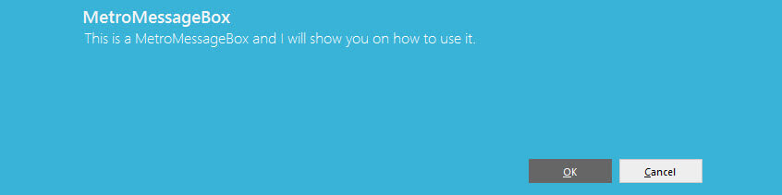

## 5.2. Success

When function is successfully done, system is prompt this message box. It colored as flat green.

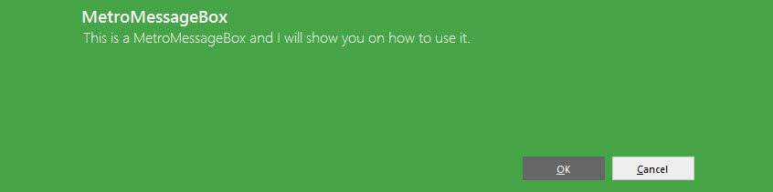

## 5.3. Error

If there any validation error or wrong interaction to the system is prompt this message box. It colored as flat red.

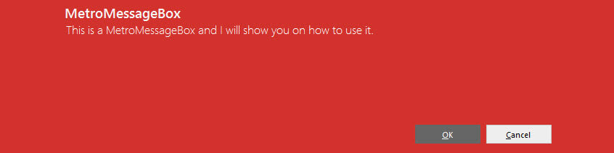

## 5.4. Warning

If user working with unhandled task or system undefined task, CITITO will prompt these type of message. It colored as flat yellow.

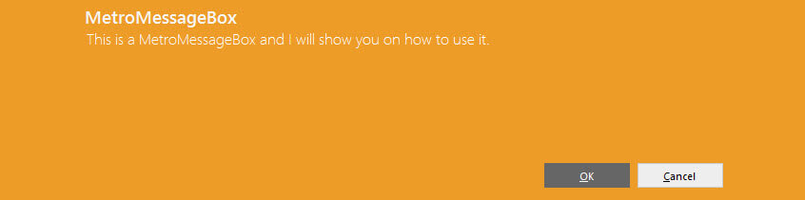

# 6. Conclusion

## 6.1. Introduction

CITITO system was developed to maintain user evaluation and productivity in single application. In agreed time span we have developed the system, after the implementation we have received more feedback from users who are entitled with the CITITO. Most of them we enhance to the current system.

## 6.2. Future Enhancement

The proposed system was developed within a time constraint and functionalities which were agreed. However as in any construction there is further room for improvement with this project and some of those potential enhancements have been listed below.

* Enhance BU head level.
* Customizable Evaluation sheet.
* Introducing email notifications using email client.
* Introducing web base system for reports.